**Module 4: Assignment 3: Database Design**

Saurabh Verma

Arizona State University

IFT 598: Middleware Programming & Database Security

Professor. Dinesh Sthapit

October 23, 2022

**Part 1: Requirements: Design**

Designed the Loan, Customer and Loan Ledger entities with their relationships:

a) The entity for the Customer must have the following properties:

Customer_ID, *Data type: Integer*

NAME, *Data type: varchar of length 30*

FIRST NAME, *Data type: varchar of length 10*

MIDDLE NAME, *Data type: varchar of length 10*

LAST NAME, *Data type: varchar of length 10*

DATE OF BIRTH, *Data type: DATE*

GENDER, *Data type: char*

CREATED DATE (for logging and auditing), *Data type: DATE*

MODIFIED DATE (for logging and auditing), *Data type: DATE*

IS DELETED (for logging and auditing), *Data type: BOOLEAN*

b) The entity for the LOAN must have the following properties:

Loan_ID, *Data type: Integer*

LOAN_TYPE (Home, Auto, Boat, Life), Data type: *varchar of length 30*

LOAN_NUMBER, *Data type: Integer*

AMOUNT, *Data type: float*

INTEREST_RATE, *Data type: float*

LOAN_TERM(Years), Data type: Integer

START DATE, Data type: DATE

CREATED DATE (for logging and auditing), Data type: DATE

MODIFIED DATE (for logging and auditing), Data type: DATE

IS DELETED (for logging and auditing), *Data type: BOOLEAN*

c) The LOAN_LEDGER table

Legder_ID, Data type: Integer

PAYMENT_AMOUNT, *Data type: float*

INTEREST, *Data type: float*

PRINCIPAL, *Data type: float*

CREATED DATE (for logging and auditing), Data type: DATE

MODIFIED DATE (for logging and auditing), Data type: DATE

IS DELETED (for logging and auditing), *Data type: BOOLEAN*

**Relationship between entities**:

* Customer and loan:
  + One customer can have one or many loans. One loan will be associated with one and only one customer. Customer table will have a foreign key which will be primary key of loan table namely Loan_number.
* Loan and Loan_ledger:
  + One and only loan will have onle and only one loan ledger. Loan table will have a foreign key which will be primary key of loan_ledger table namely Ledger_ID.

ERD diagram with their data types:

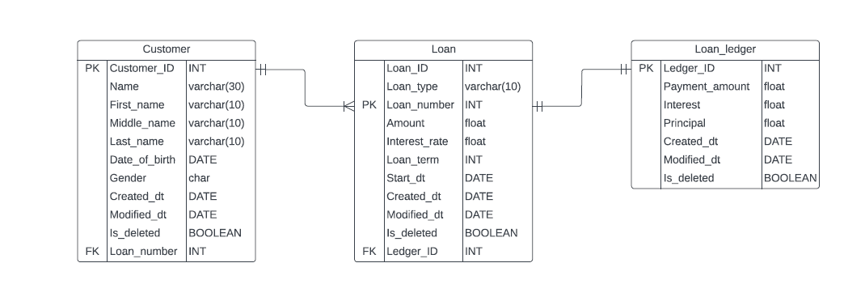

Part 2: Requirement Storage Design Implementation – Create a new database and models

Screenshot of loanModel.js:

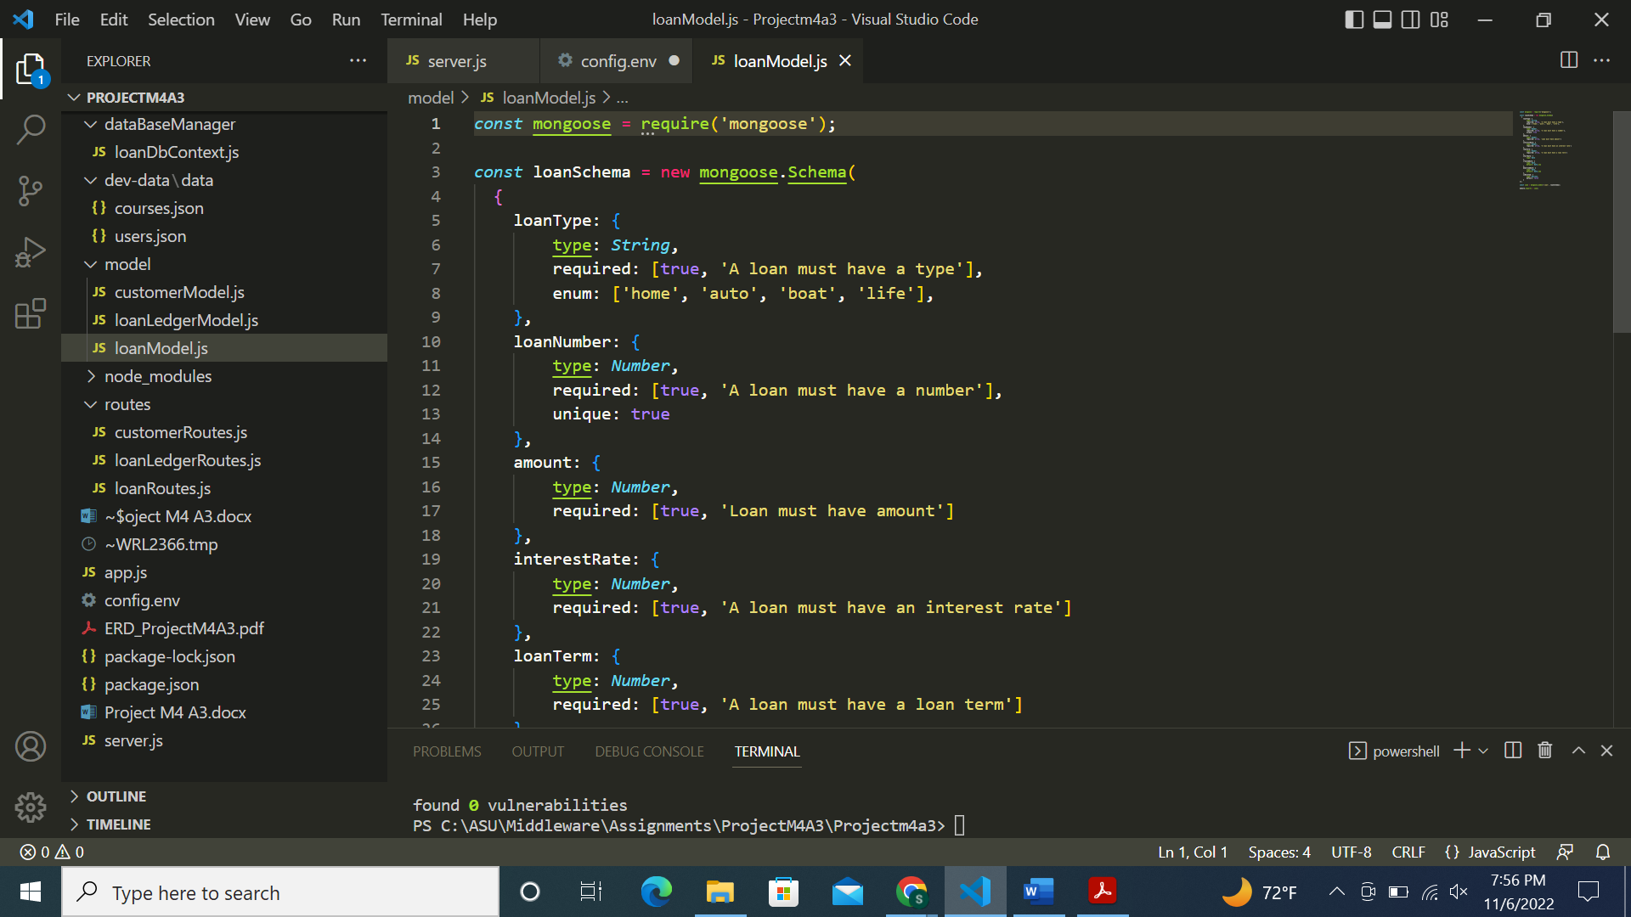

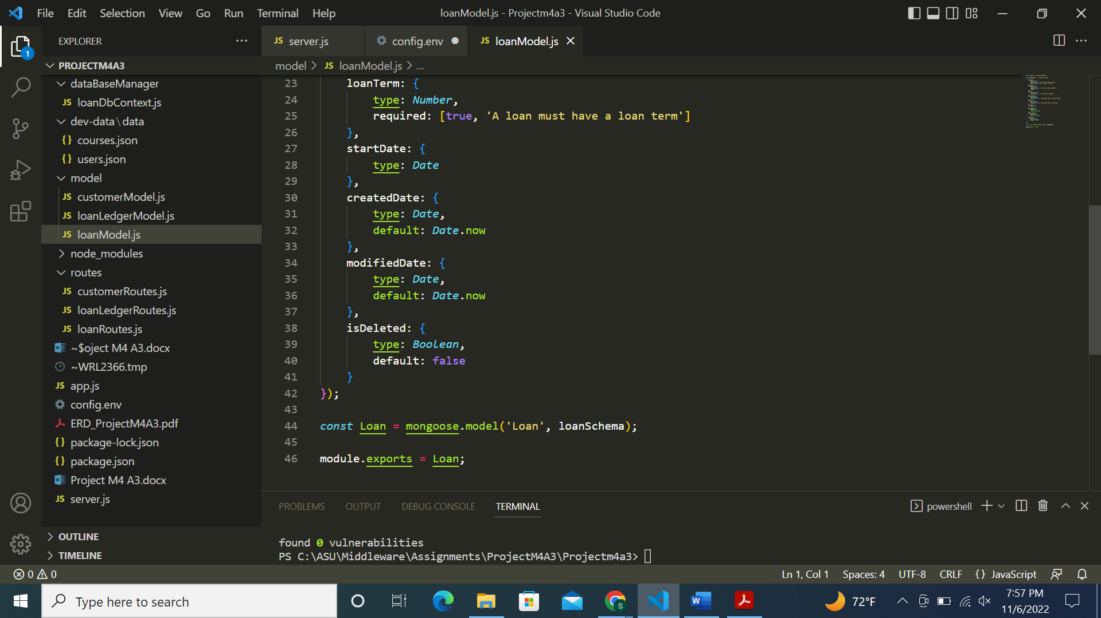

Screenshot of customerModel.js:

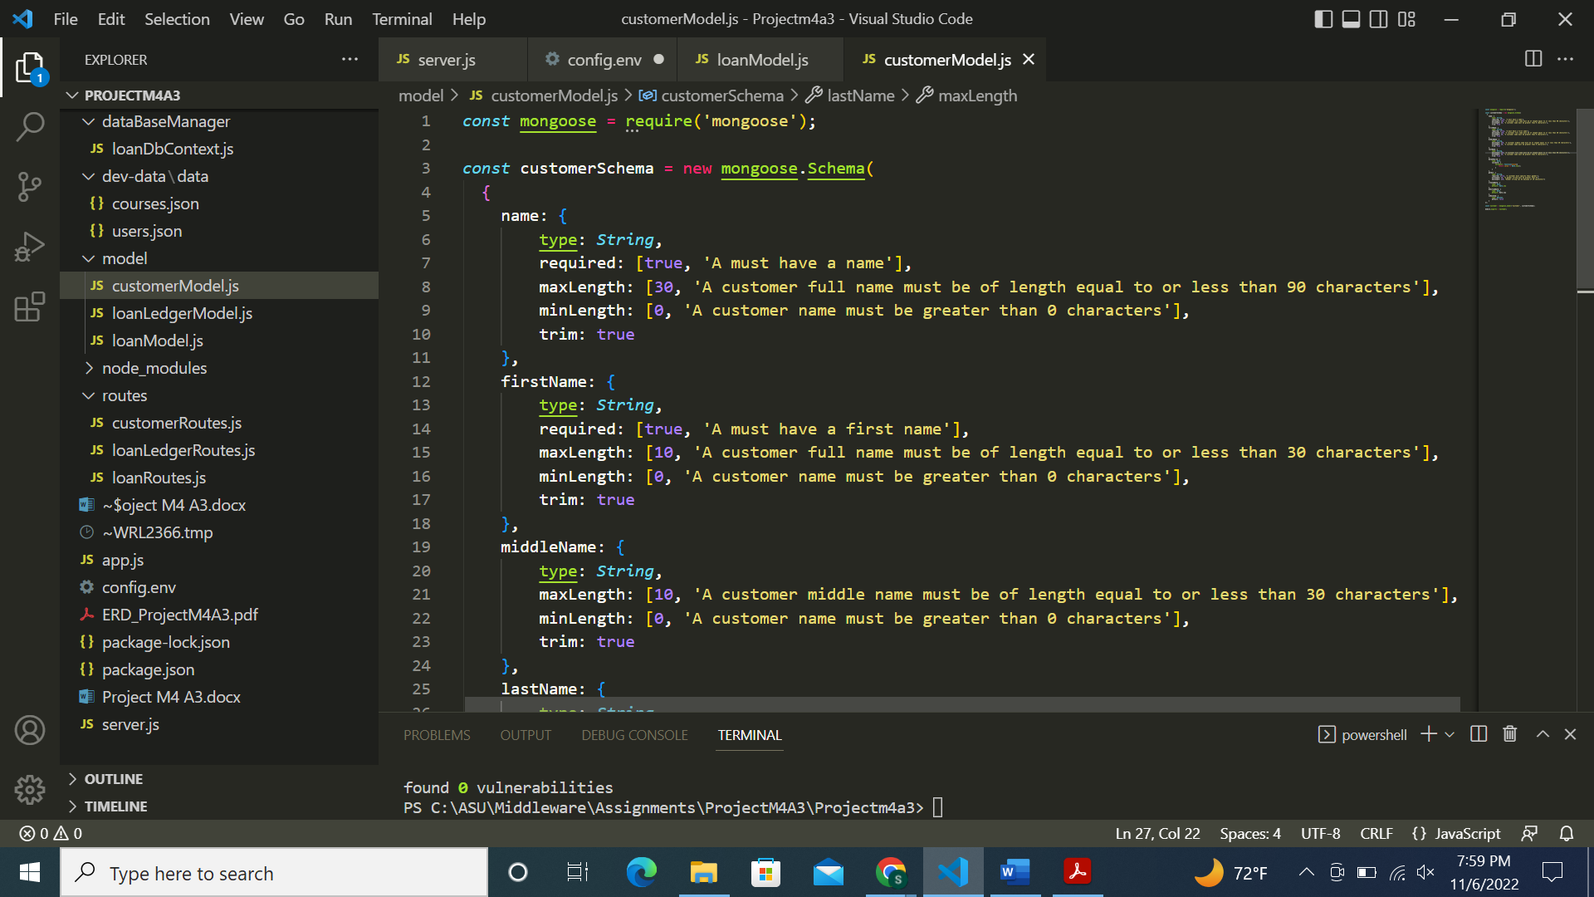

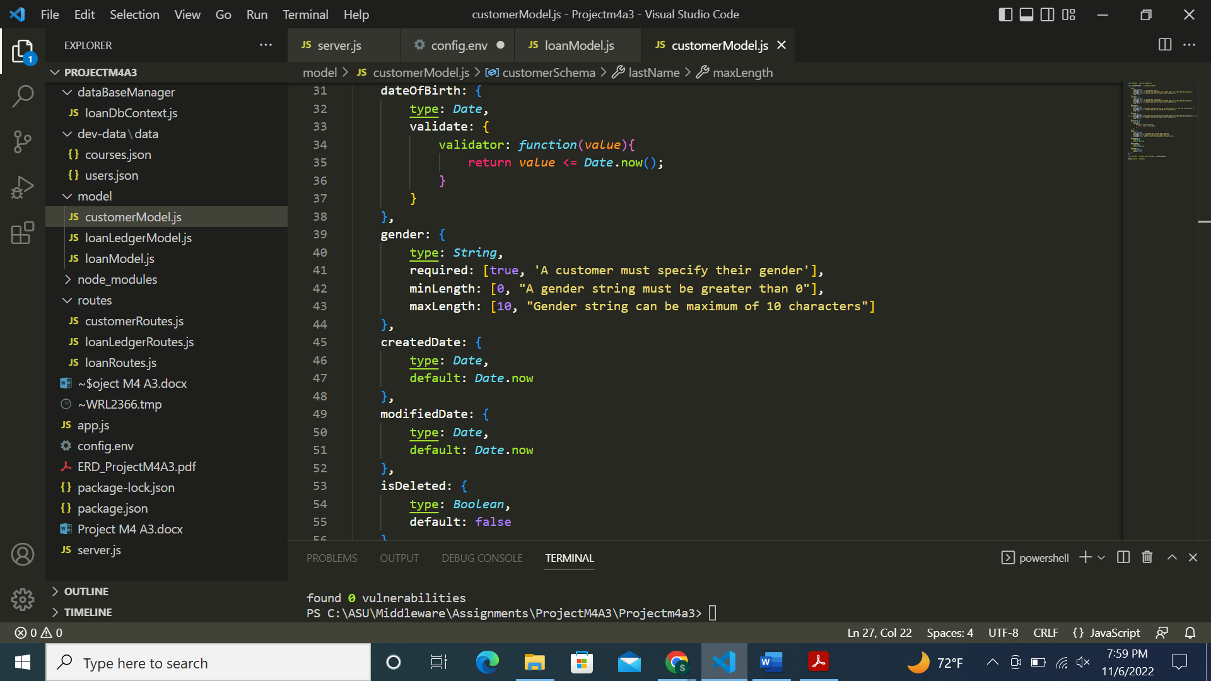

Screenshot of loanLedgerModel.js:

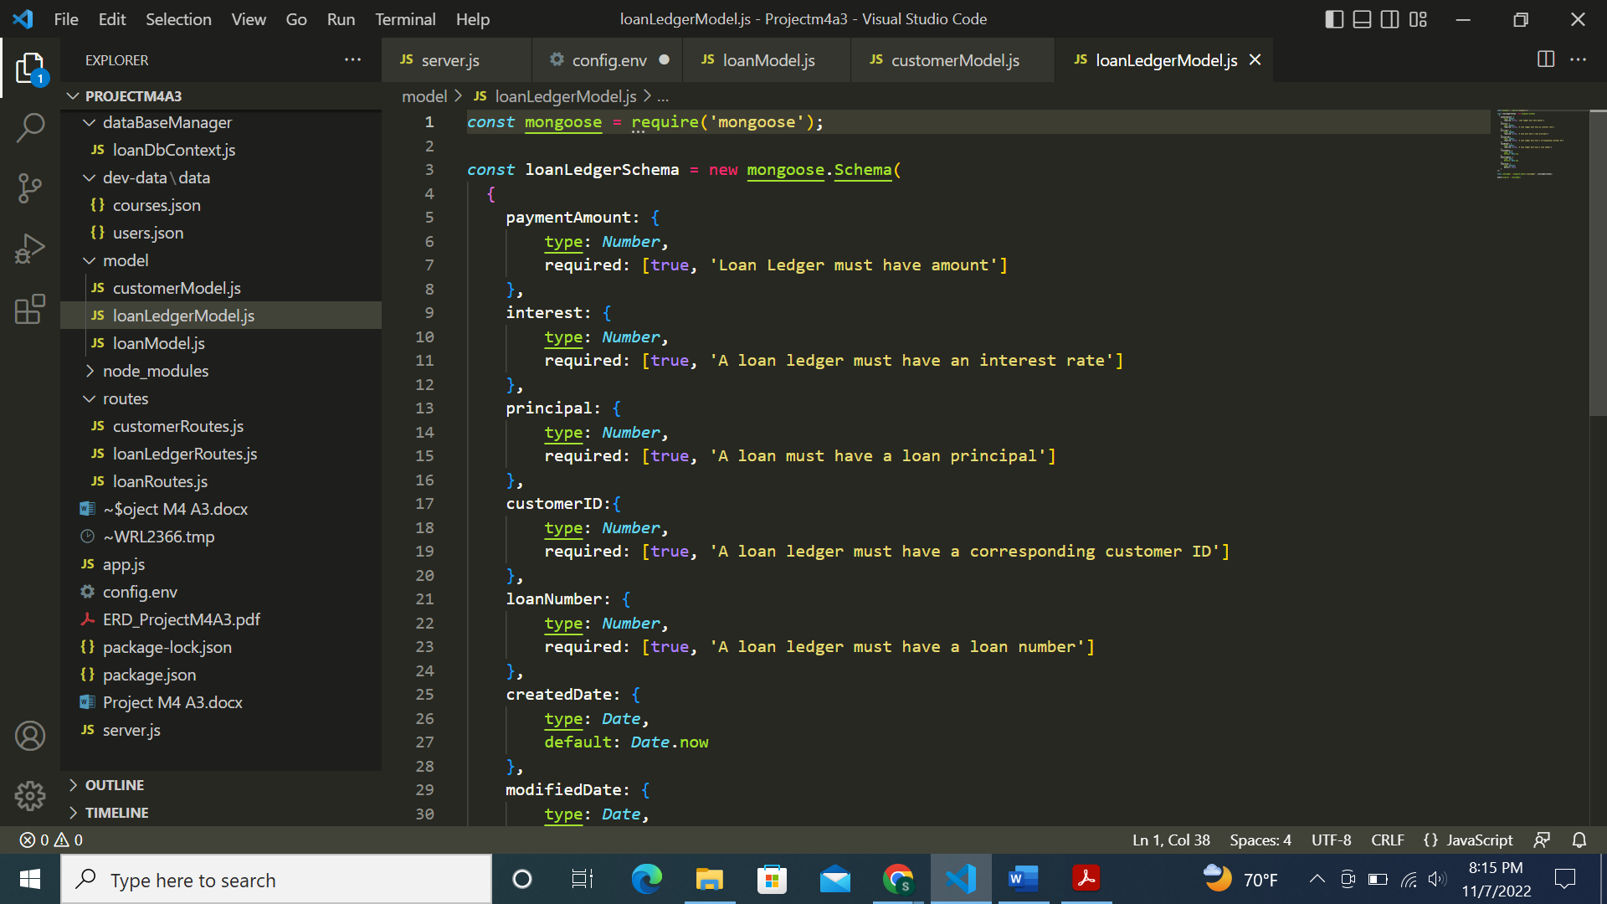

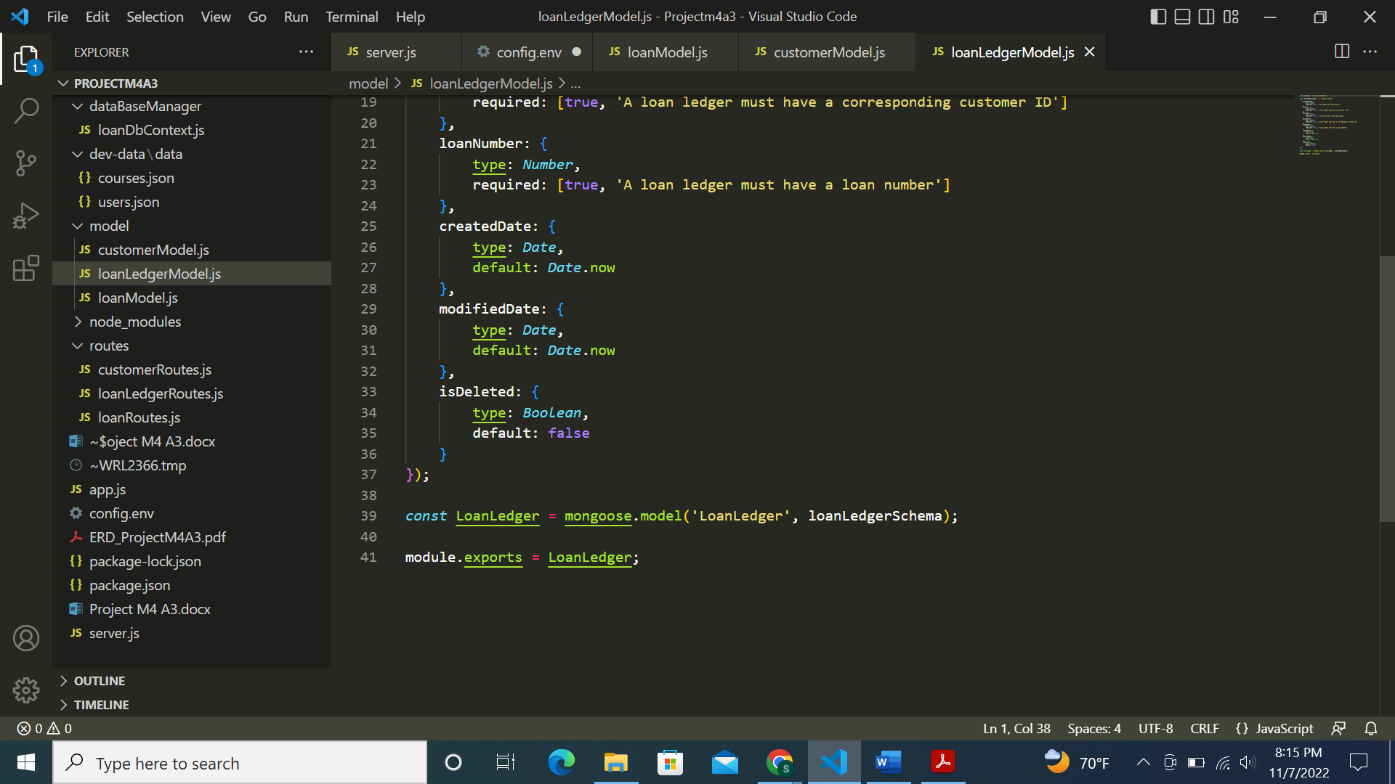

Screenshot of config.env file:

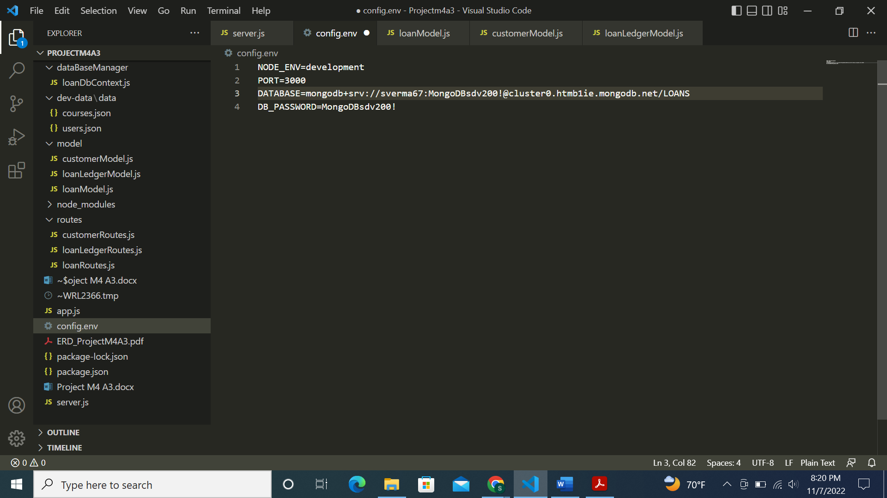

Screenshot of server.js file:

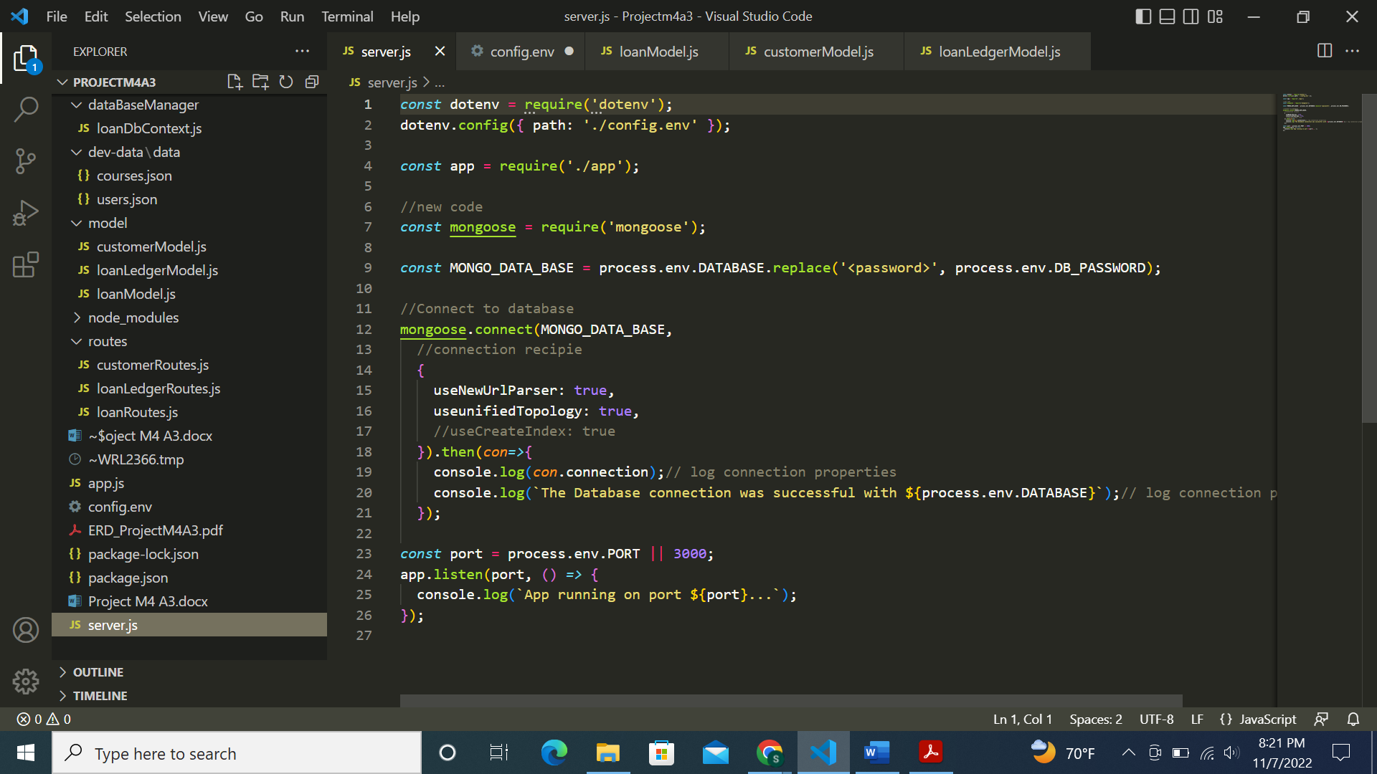

Screenshot of app.js file:

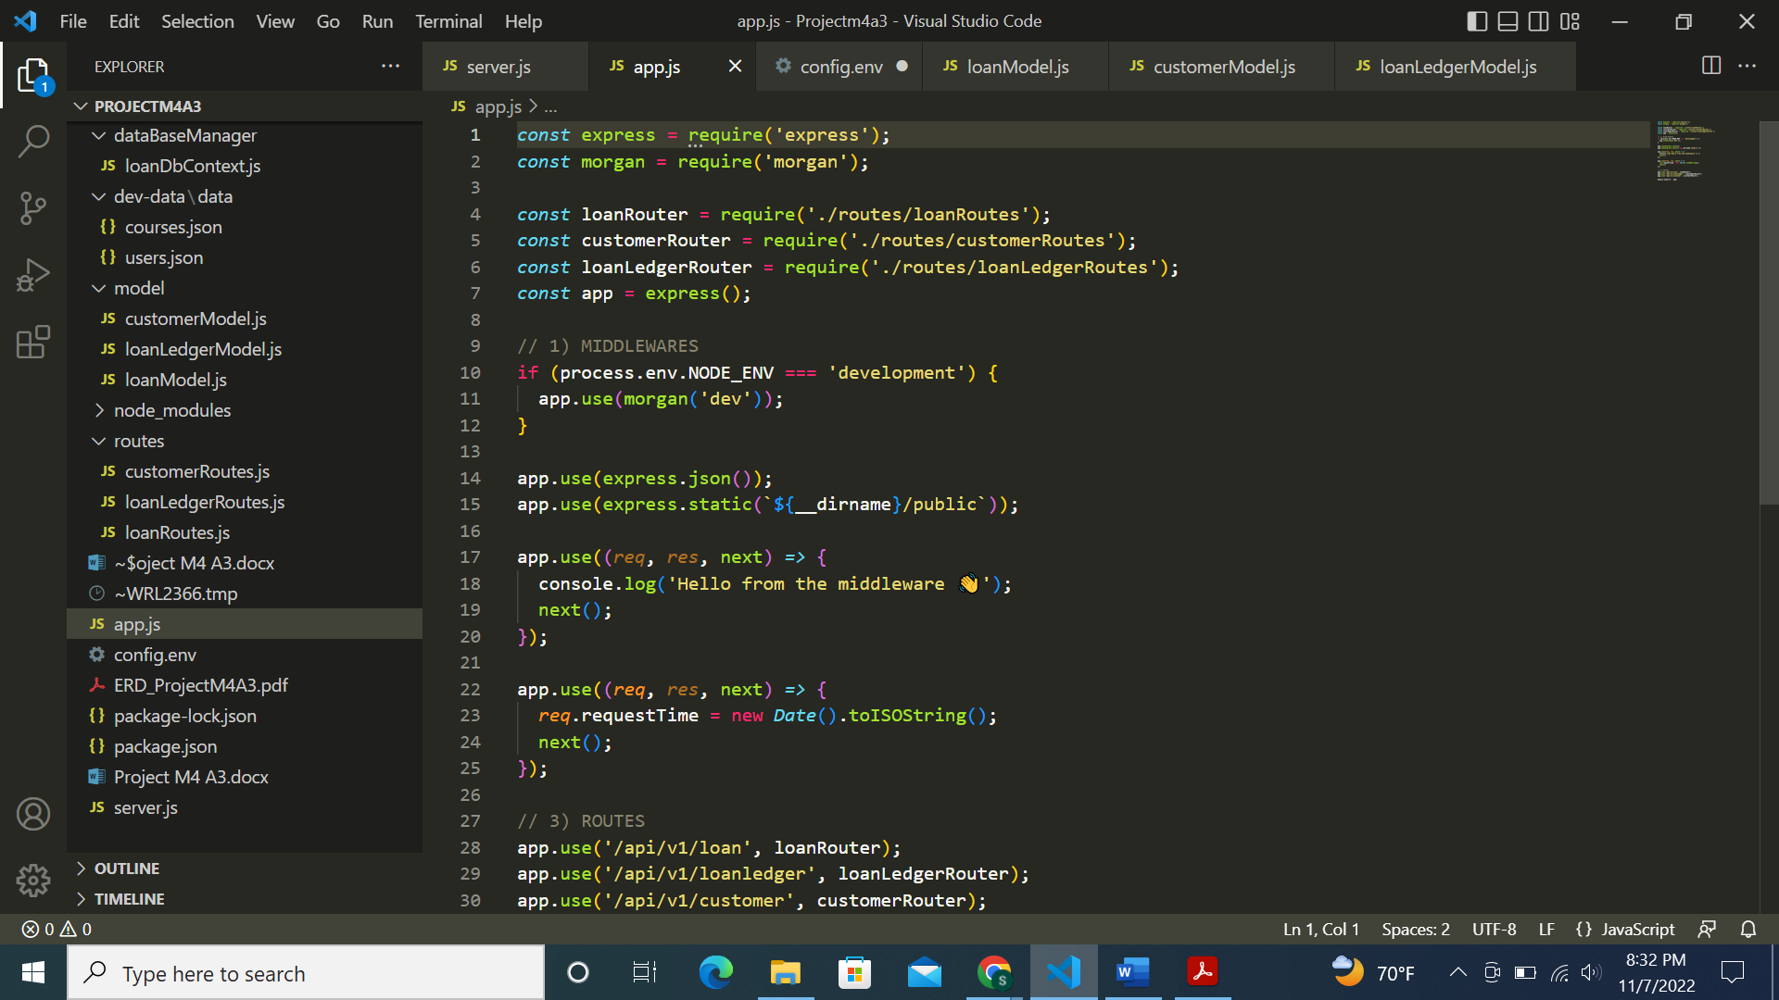

Screenshot of code run successfully:

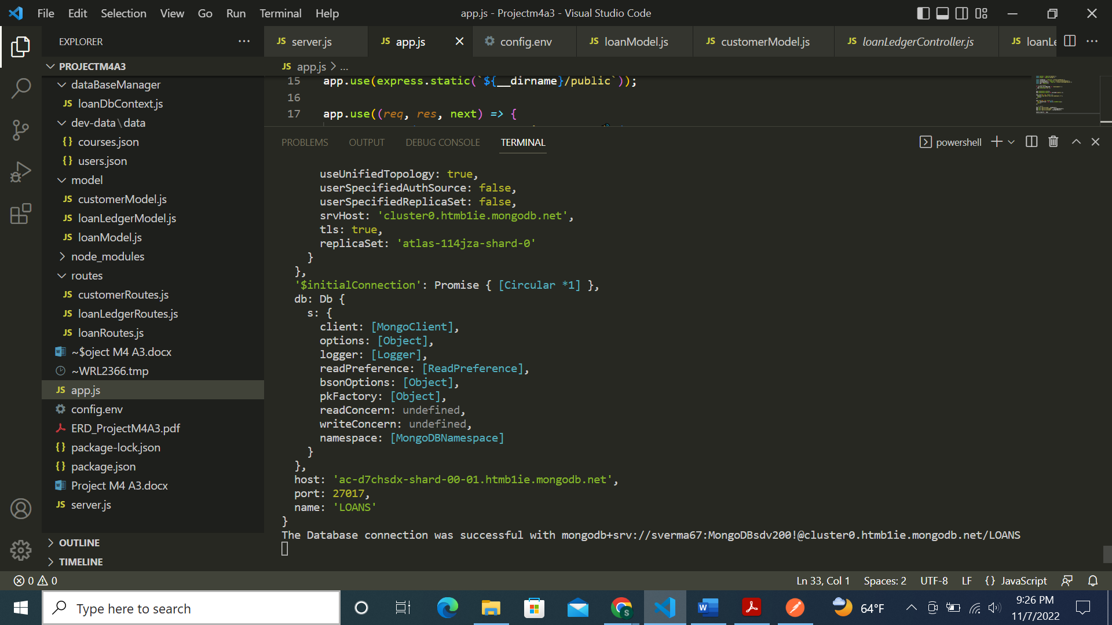

Screenshot of MongoDB with LOANS database created:

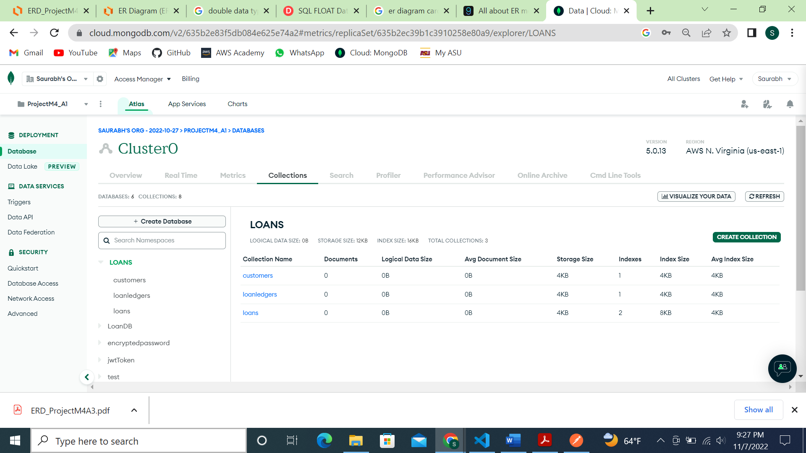

Inserting records for 10 customers in customer table:

1st record:

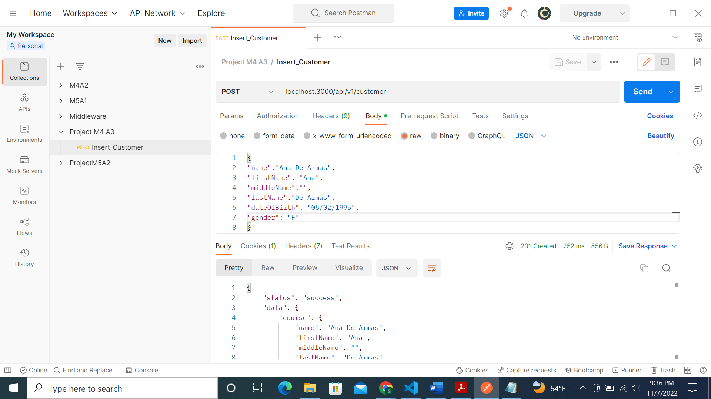

2nd record:

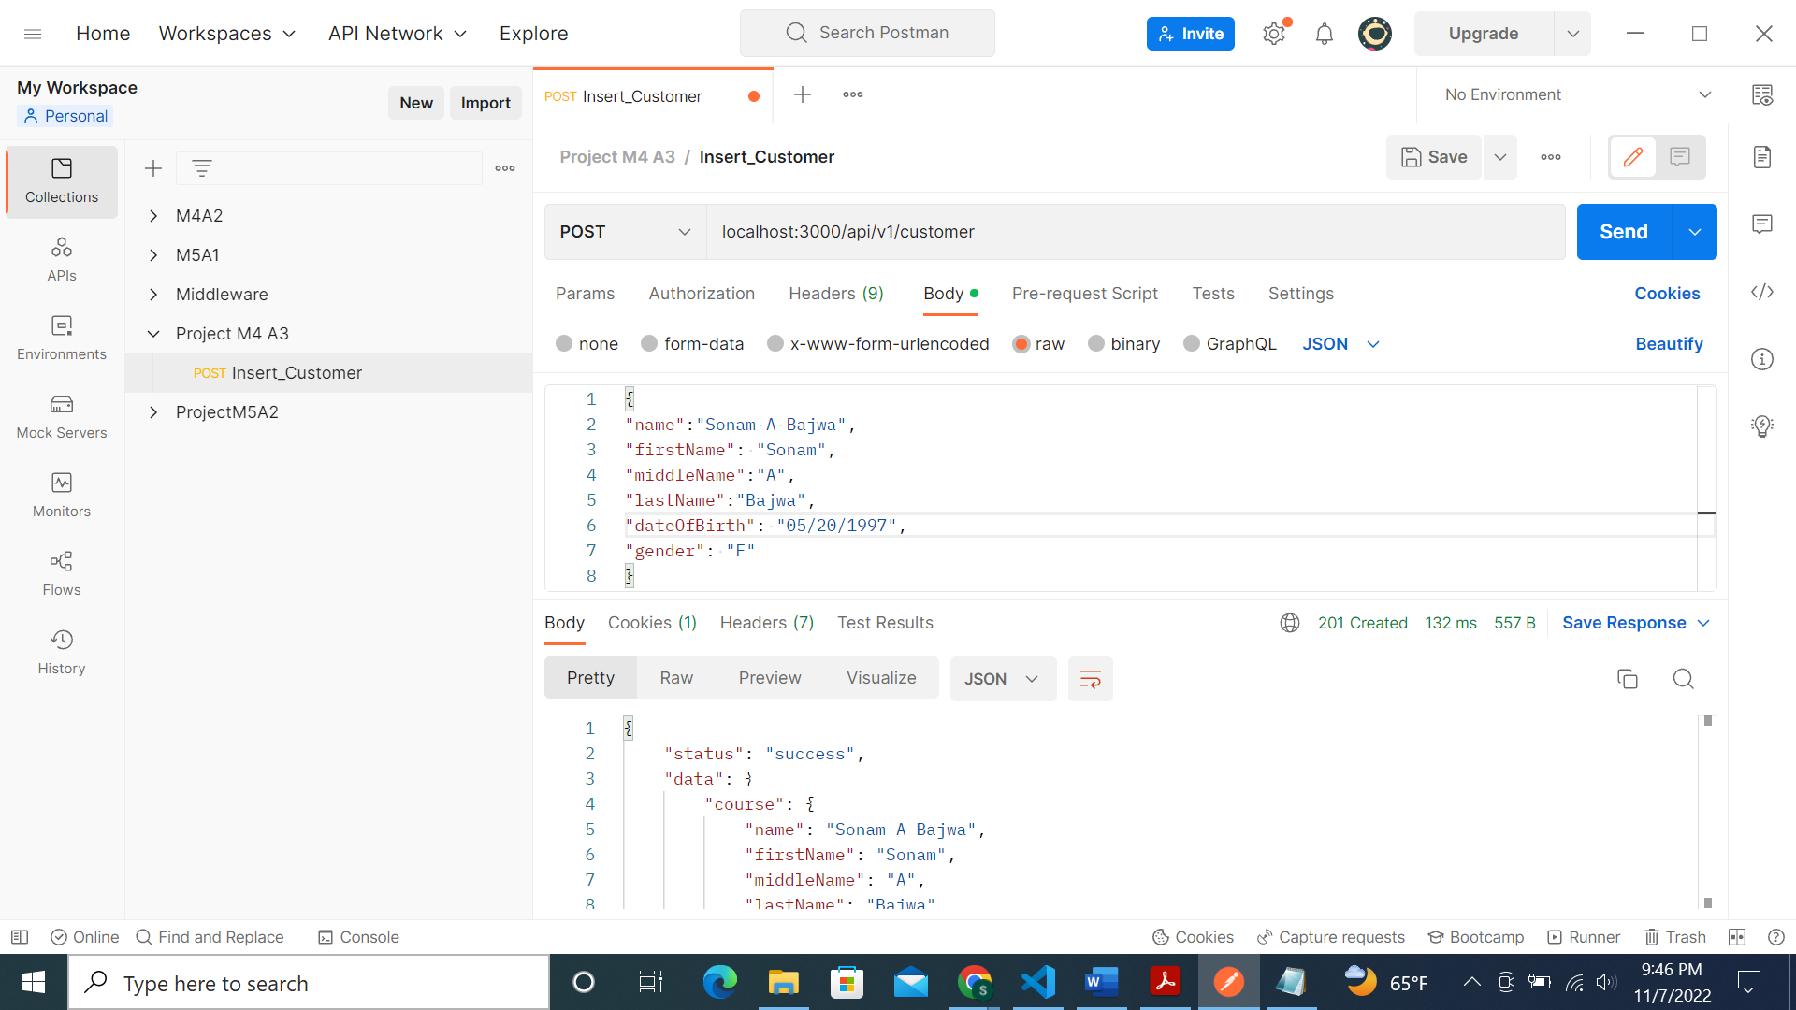

3rd record:

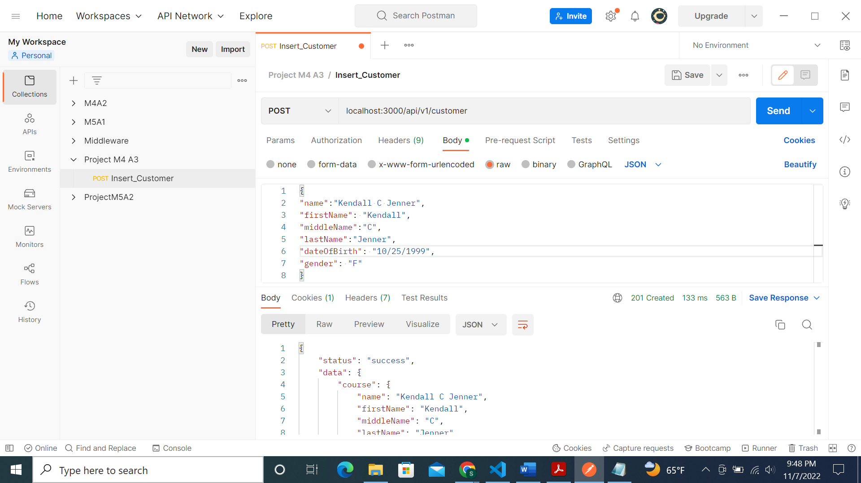

Similarly inserted in total 10 records for customer table:

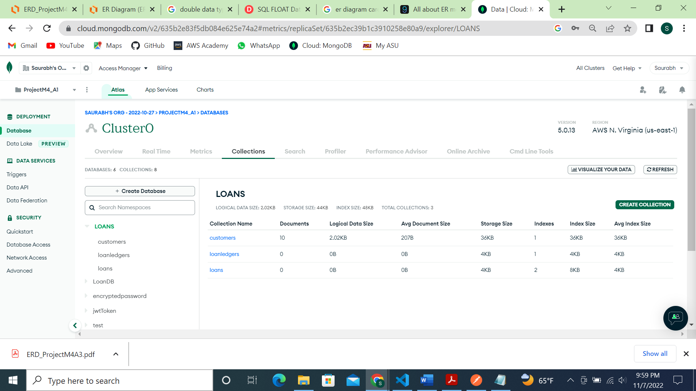

Below are the screenshots of those customers in MongoDB customer table:

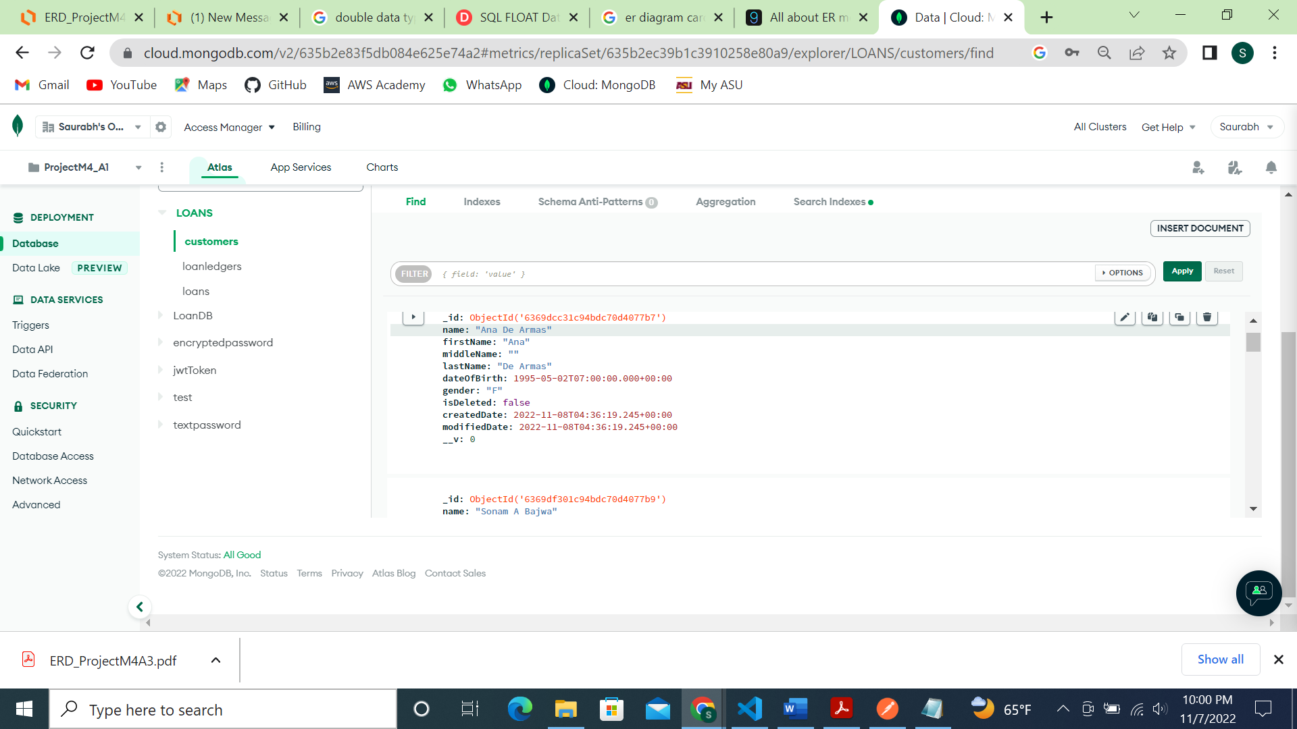

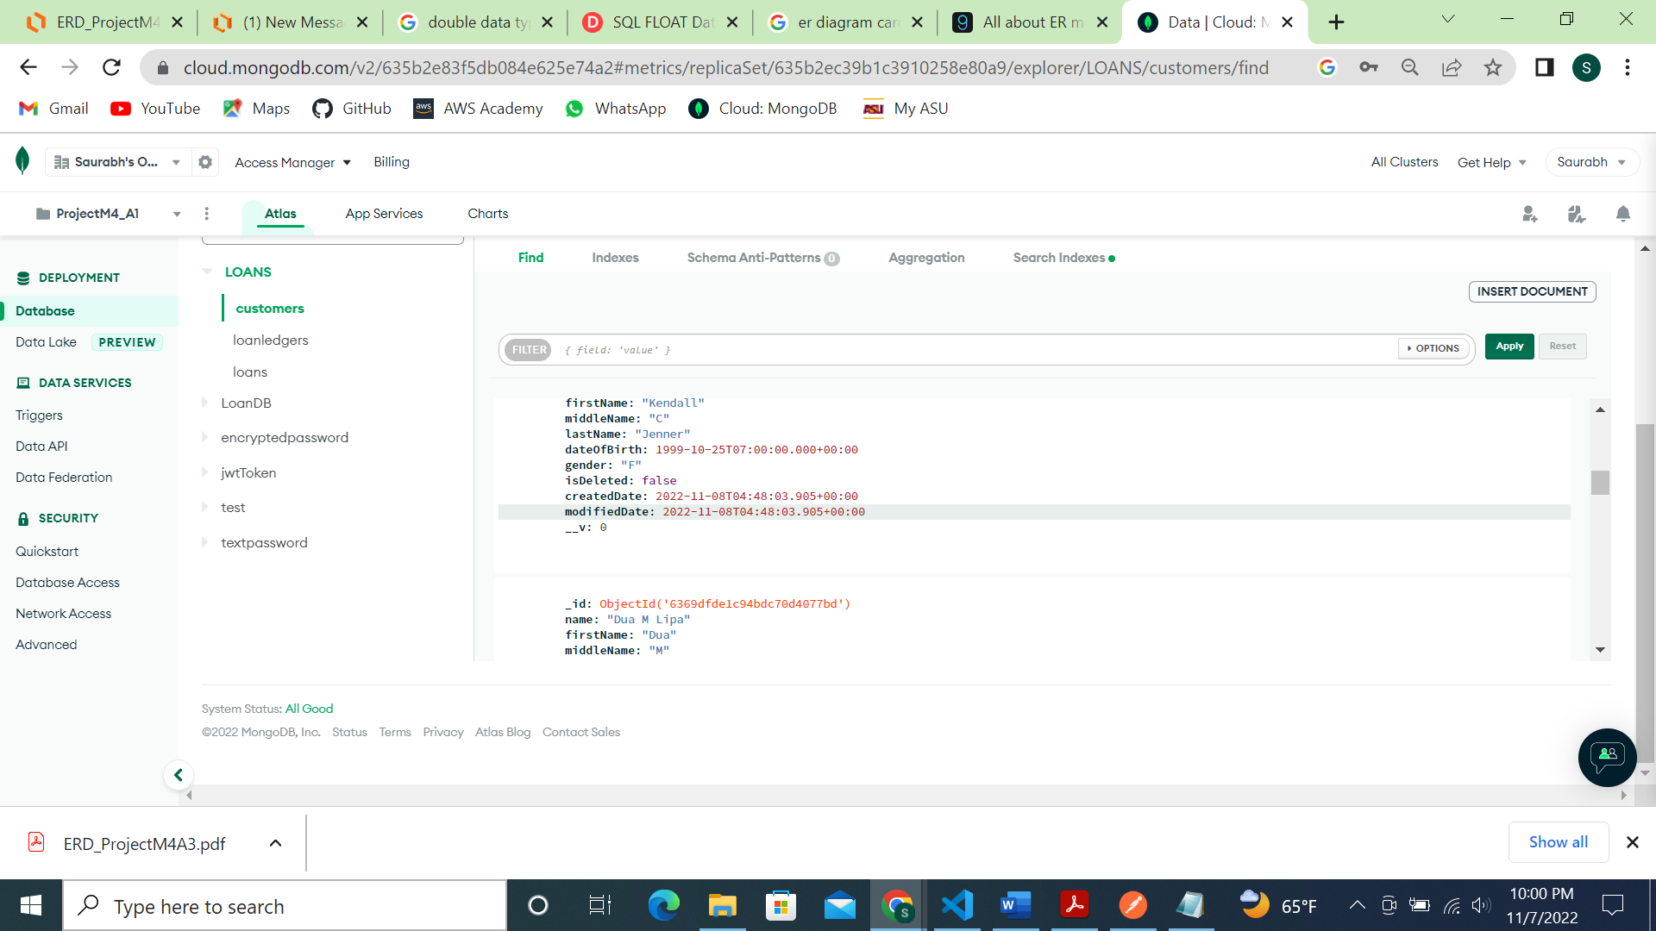

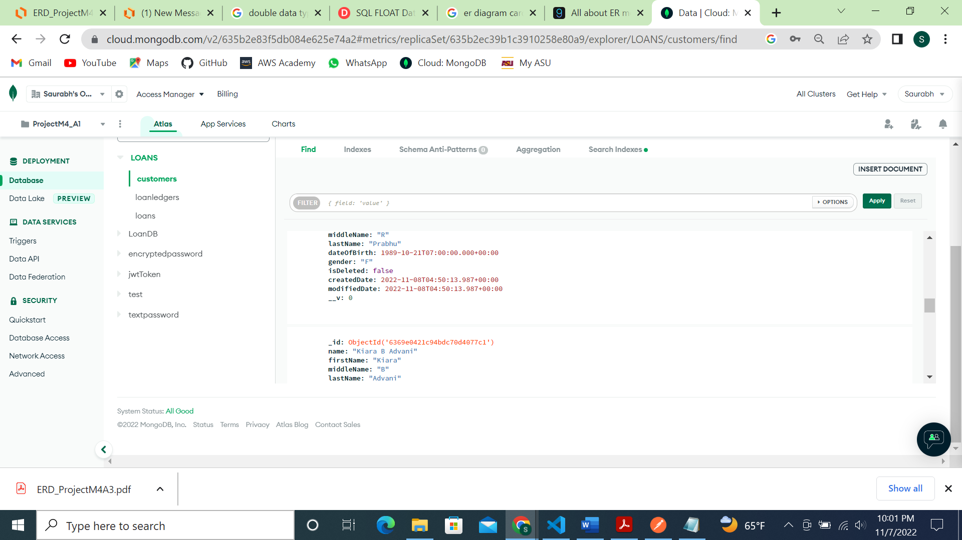

Inserting records for 3 loan types:

1st loan type:

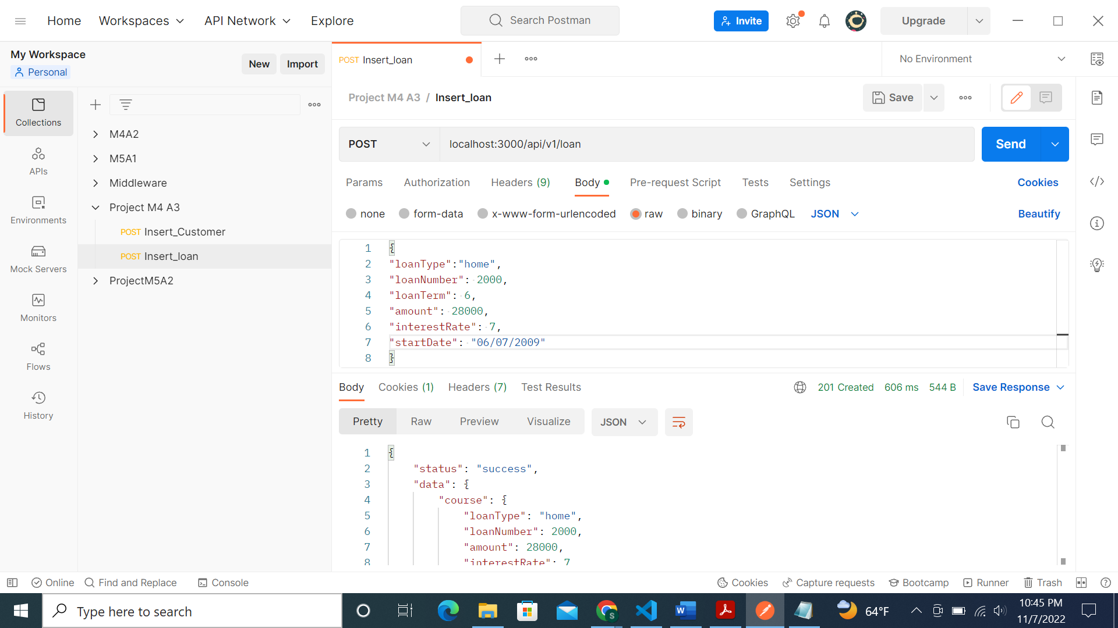

2nd loan type:

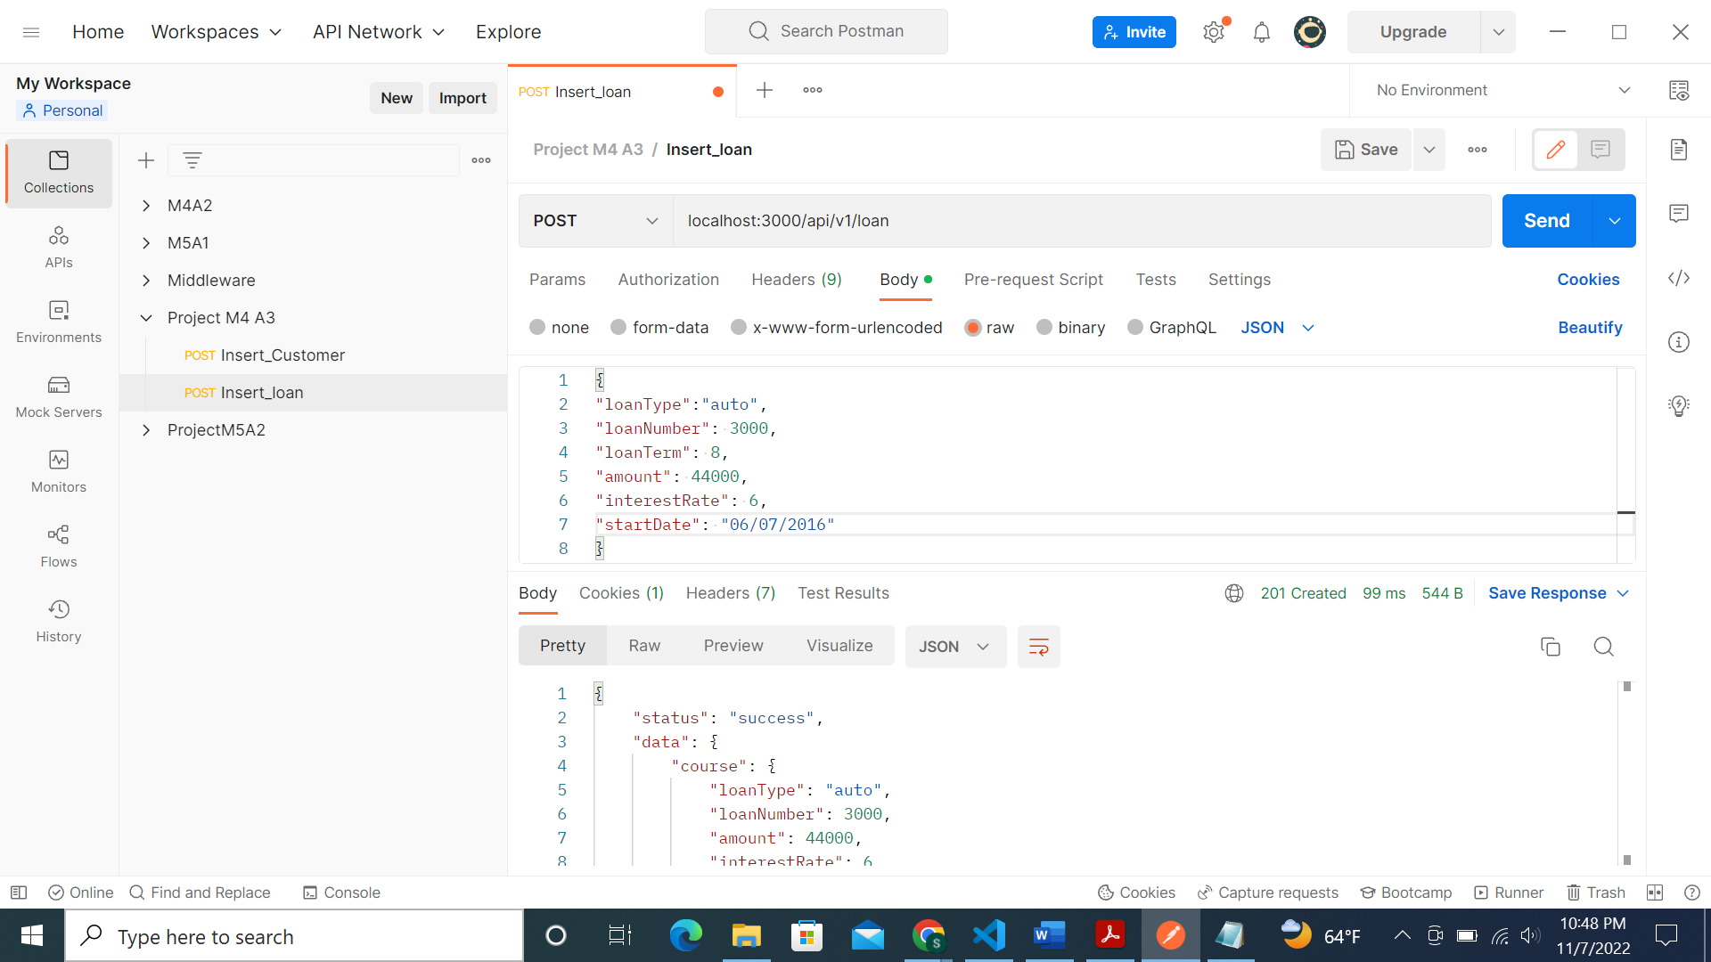

3rd loan type:

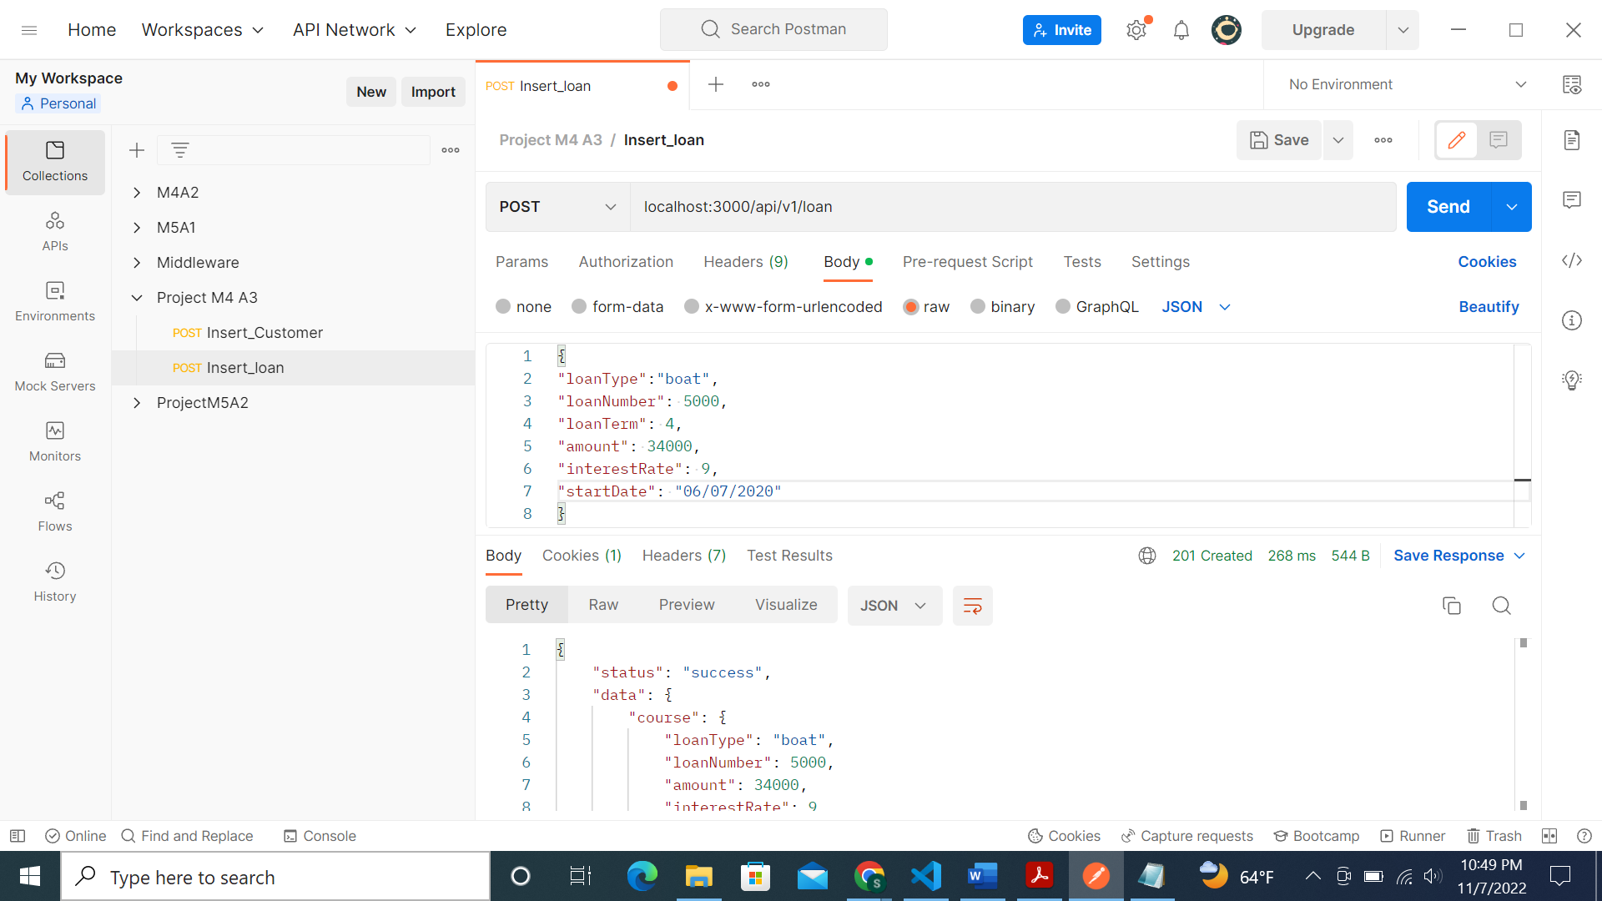

Screenshot of MongoDB loan table:

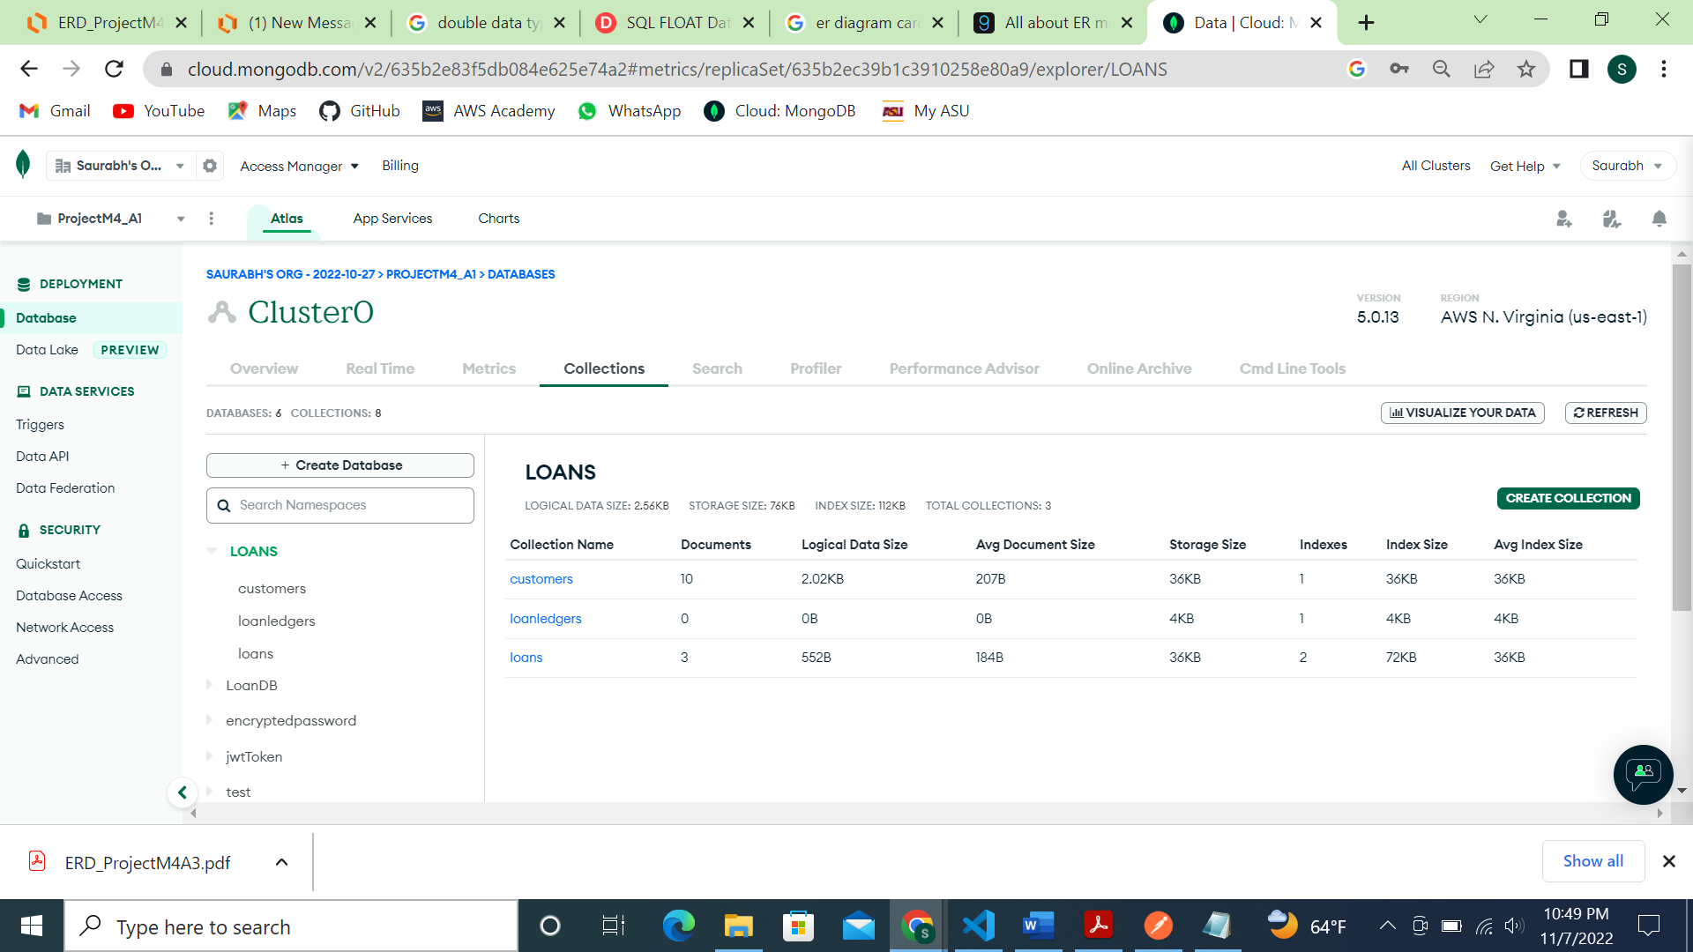

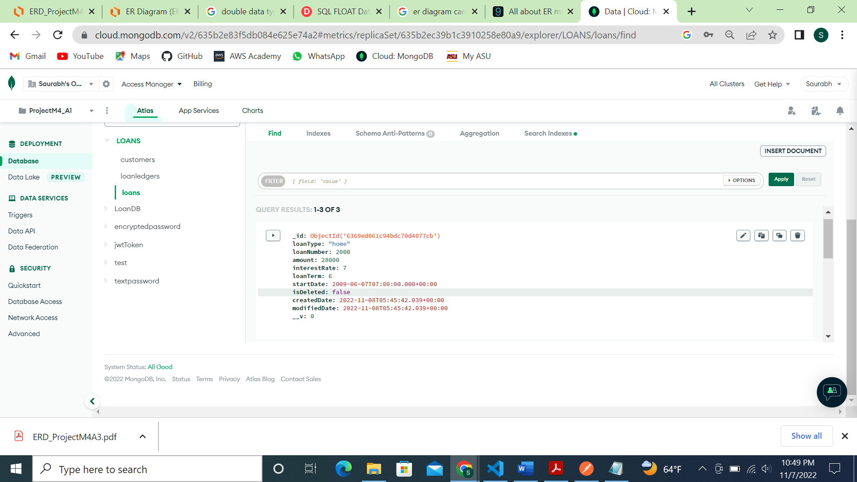

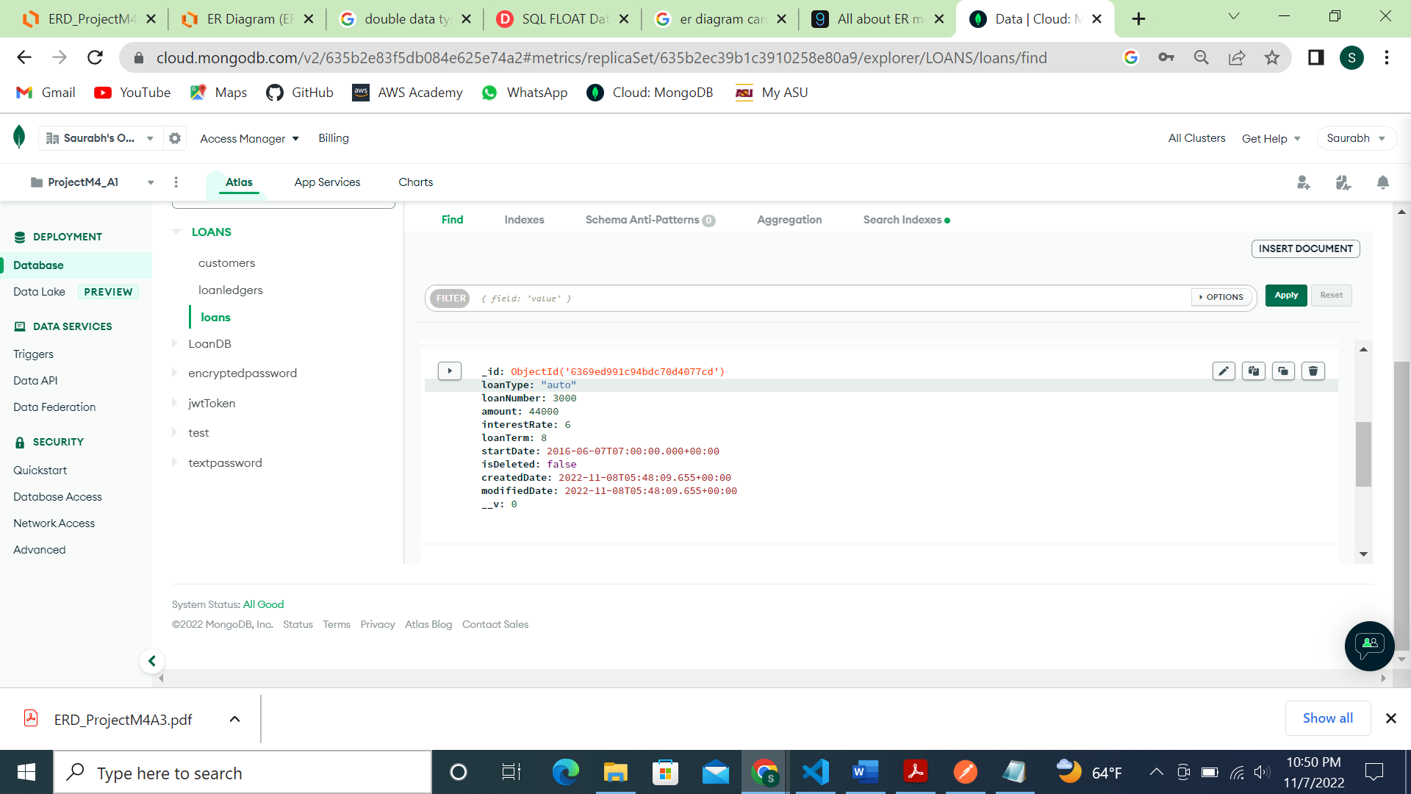

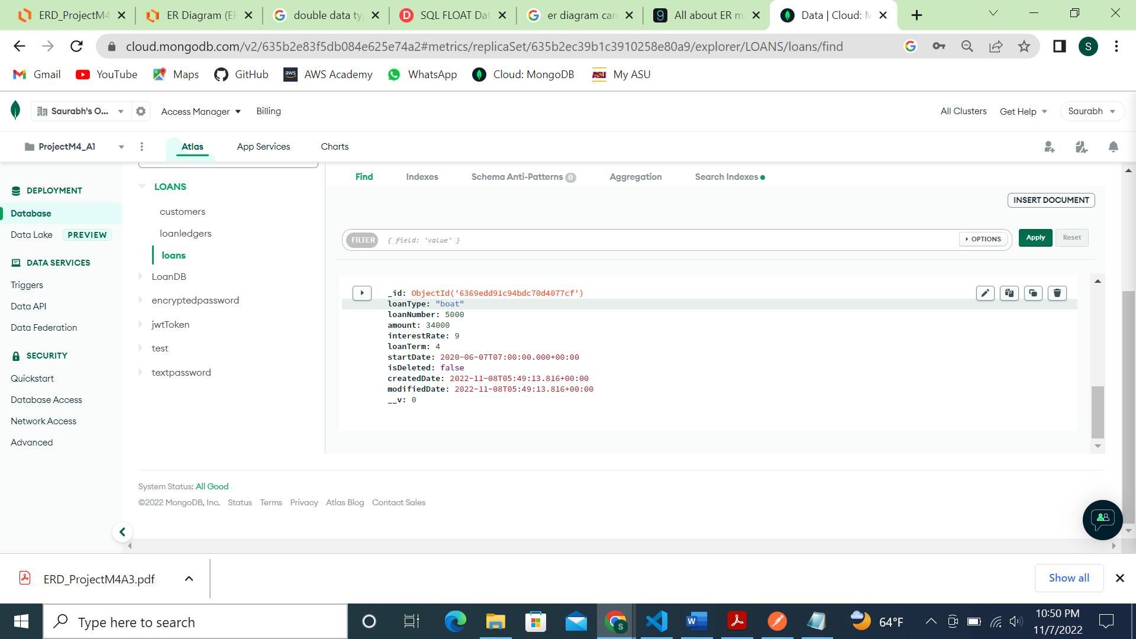

Inserting 2 payment loanledger records for 5 customers:

Inserting loan ledger 1 for customer 1:

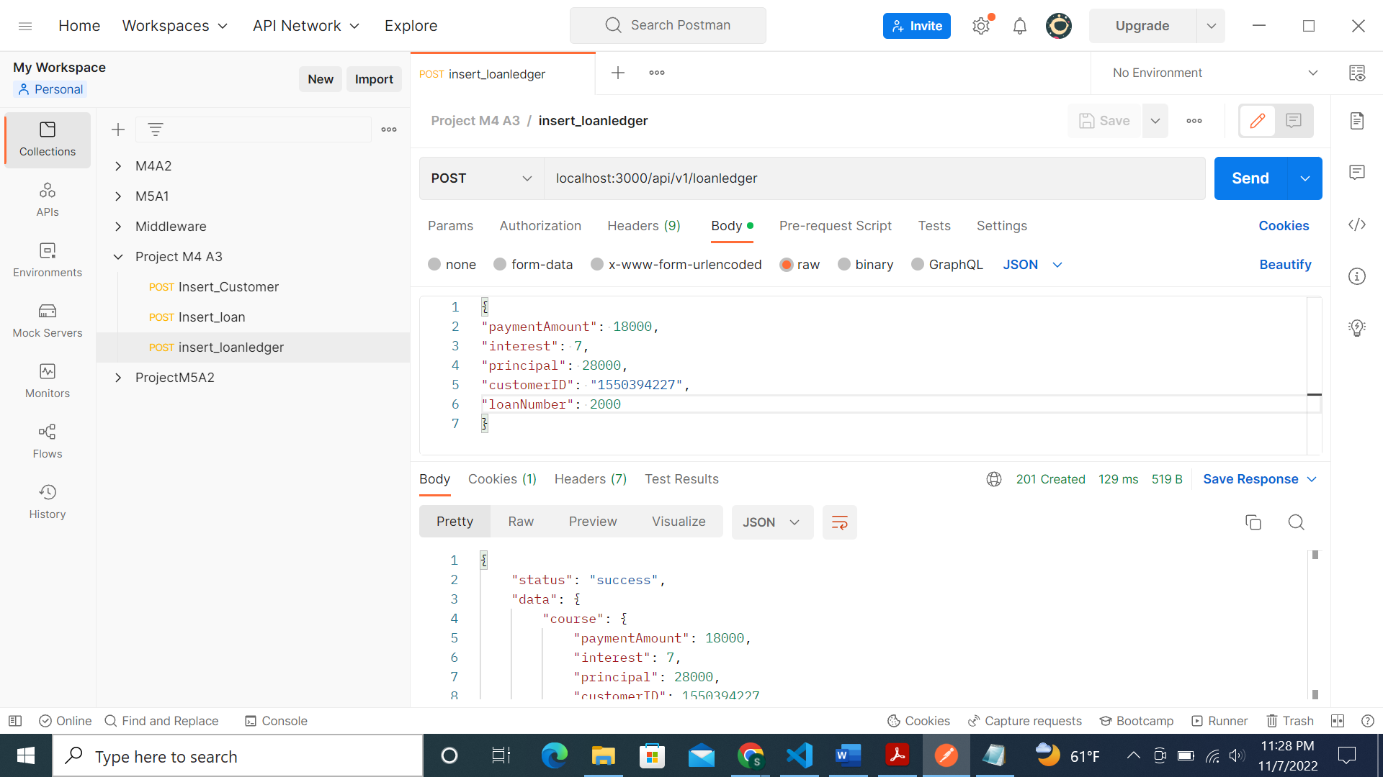

Screenshot for loan ledger 2 for customer 1:

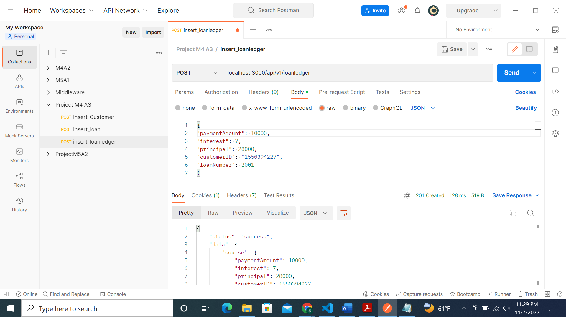

Screenshot of loan ledger 1 of customer 2:

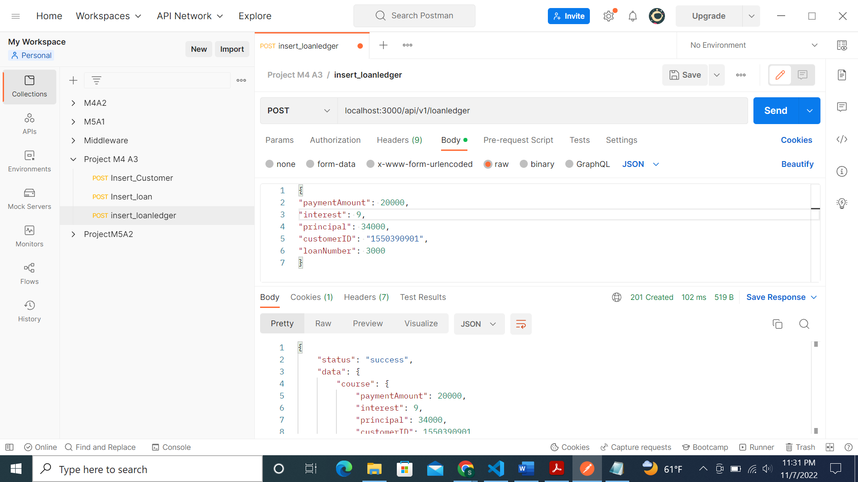

Screenshot of loan ledger 2 of customer 2:

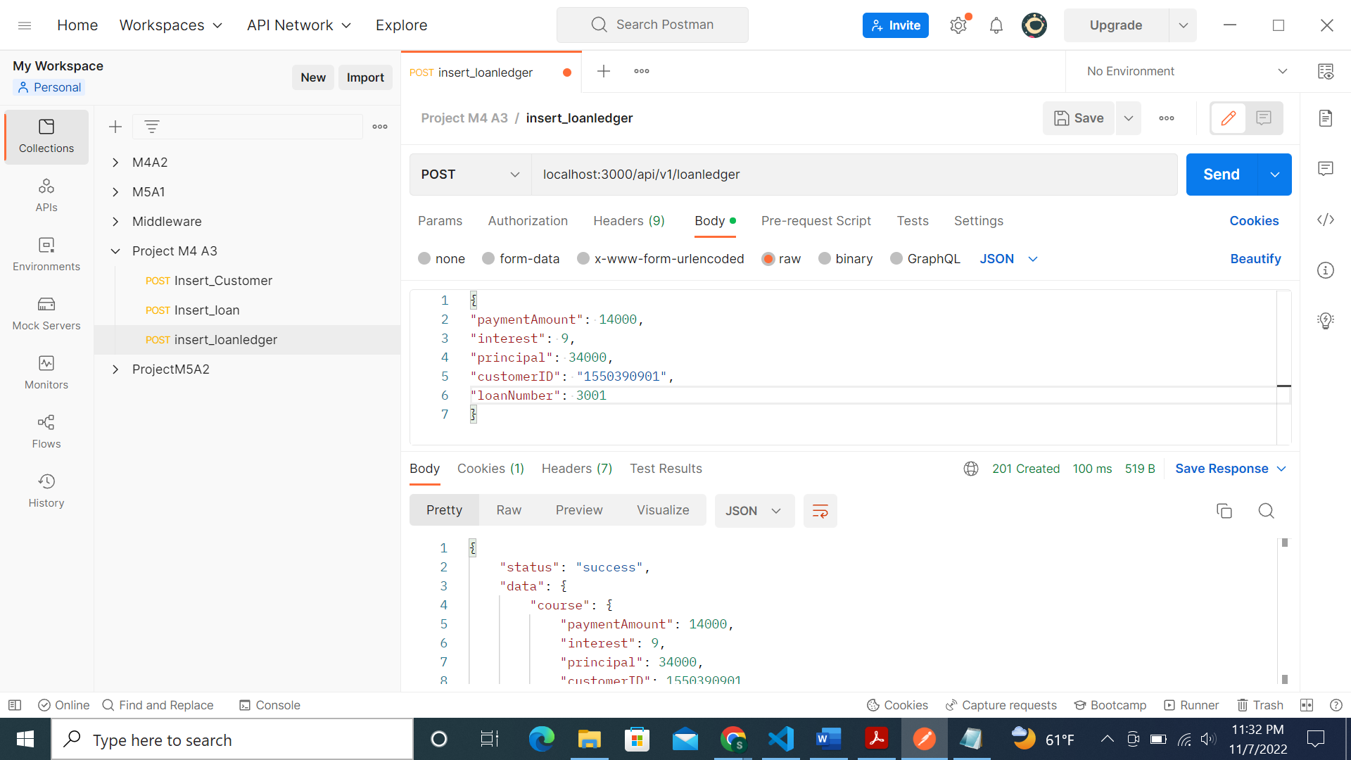

Similarly for 3 more customers we have inserted 2 loan ledgers each:

Total 10 records in loan ledger table:

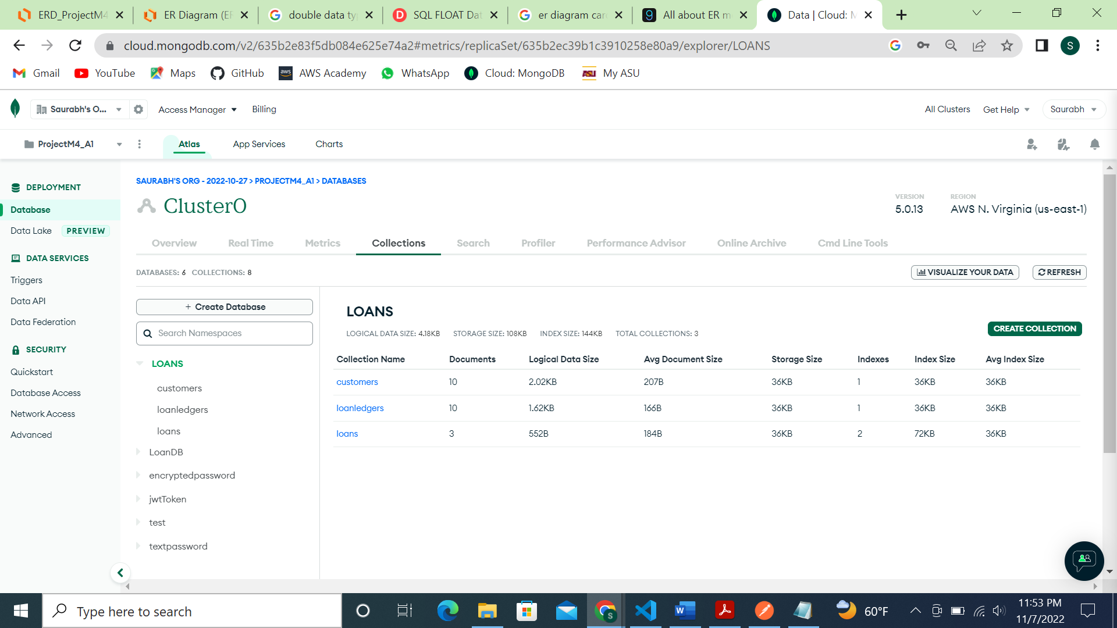

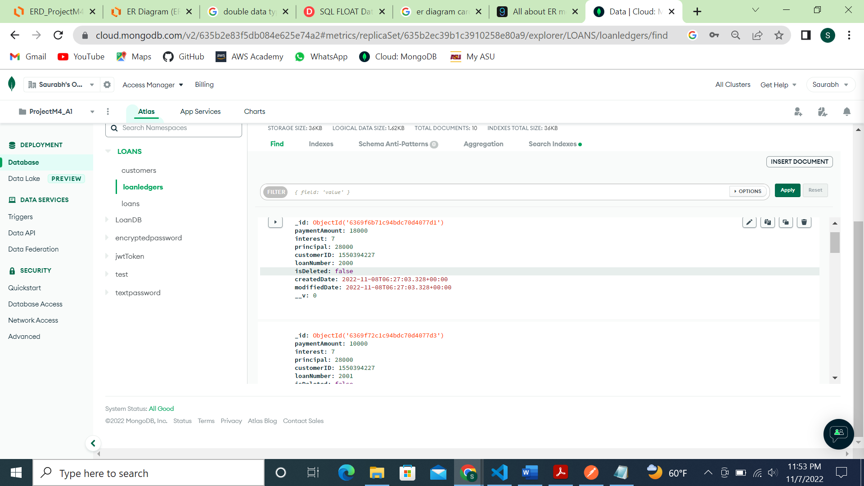

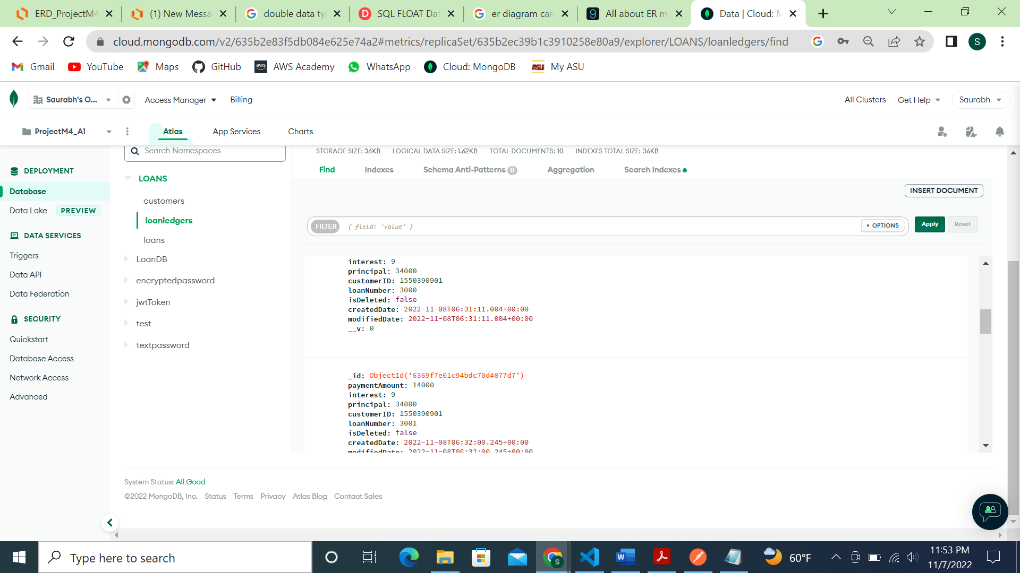

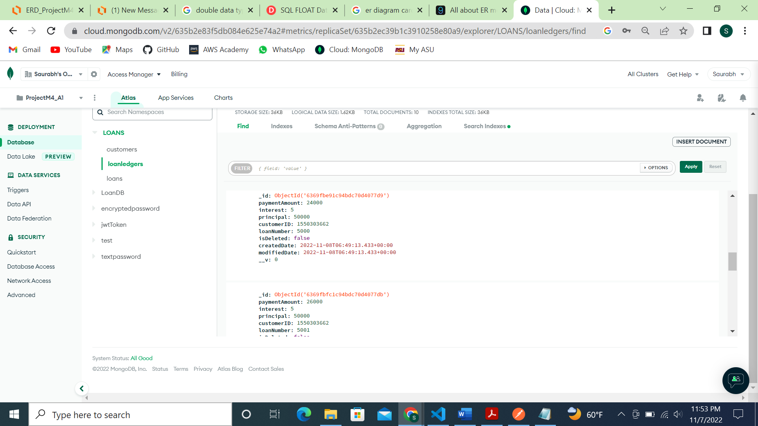

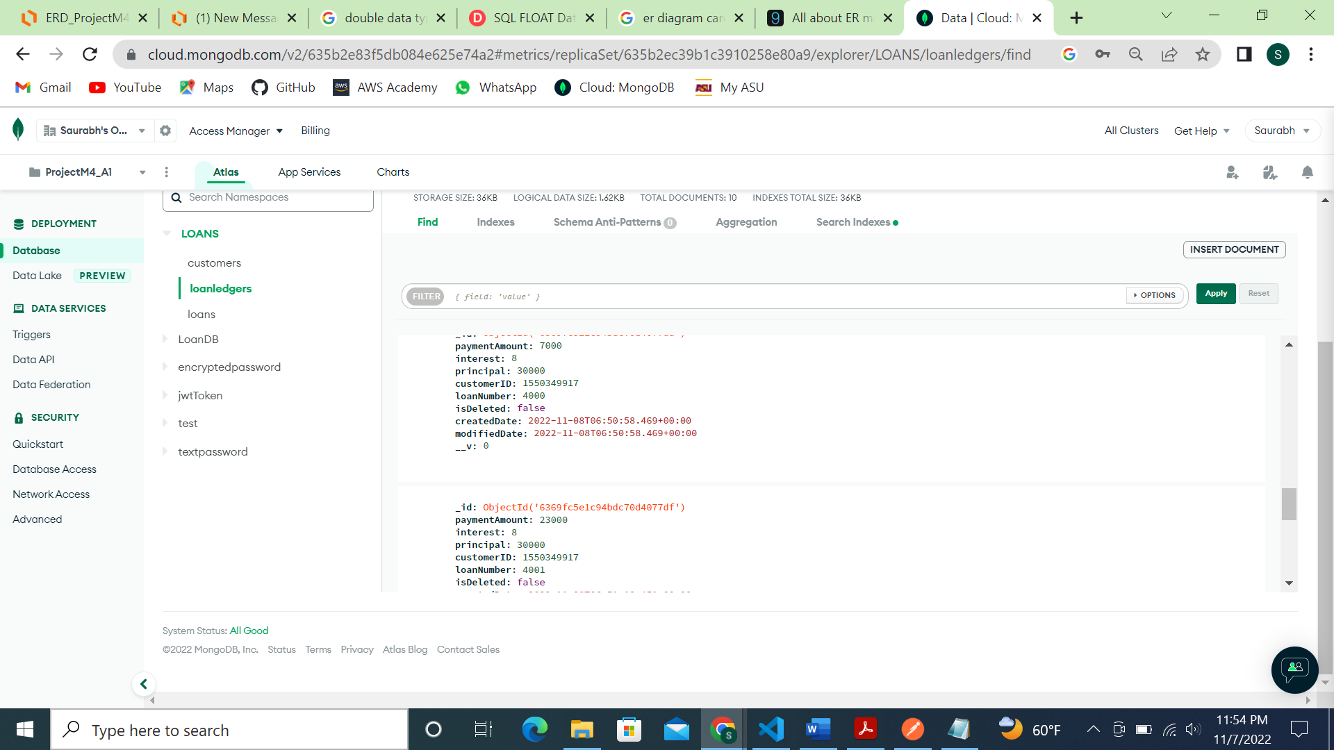

Part 3: Requirement Storage Design Implementation.

Screenshot of controller files:

customerController.js file:

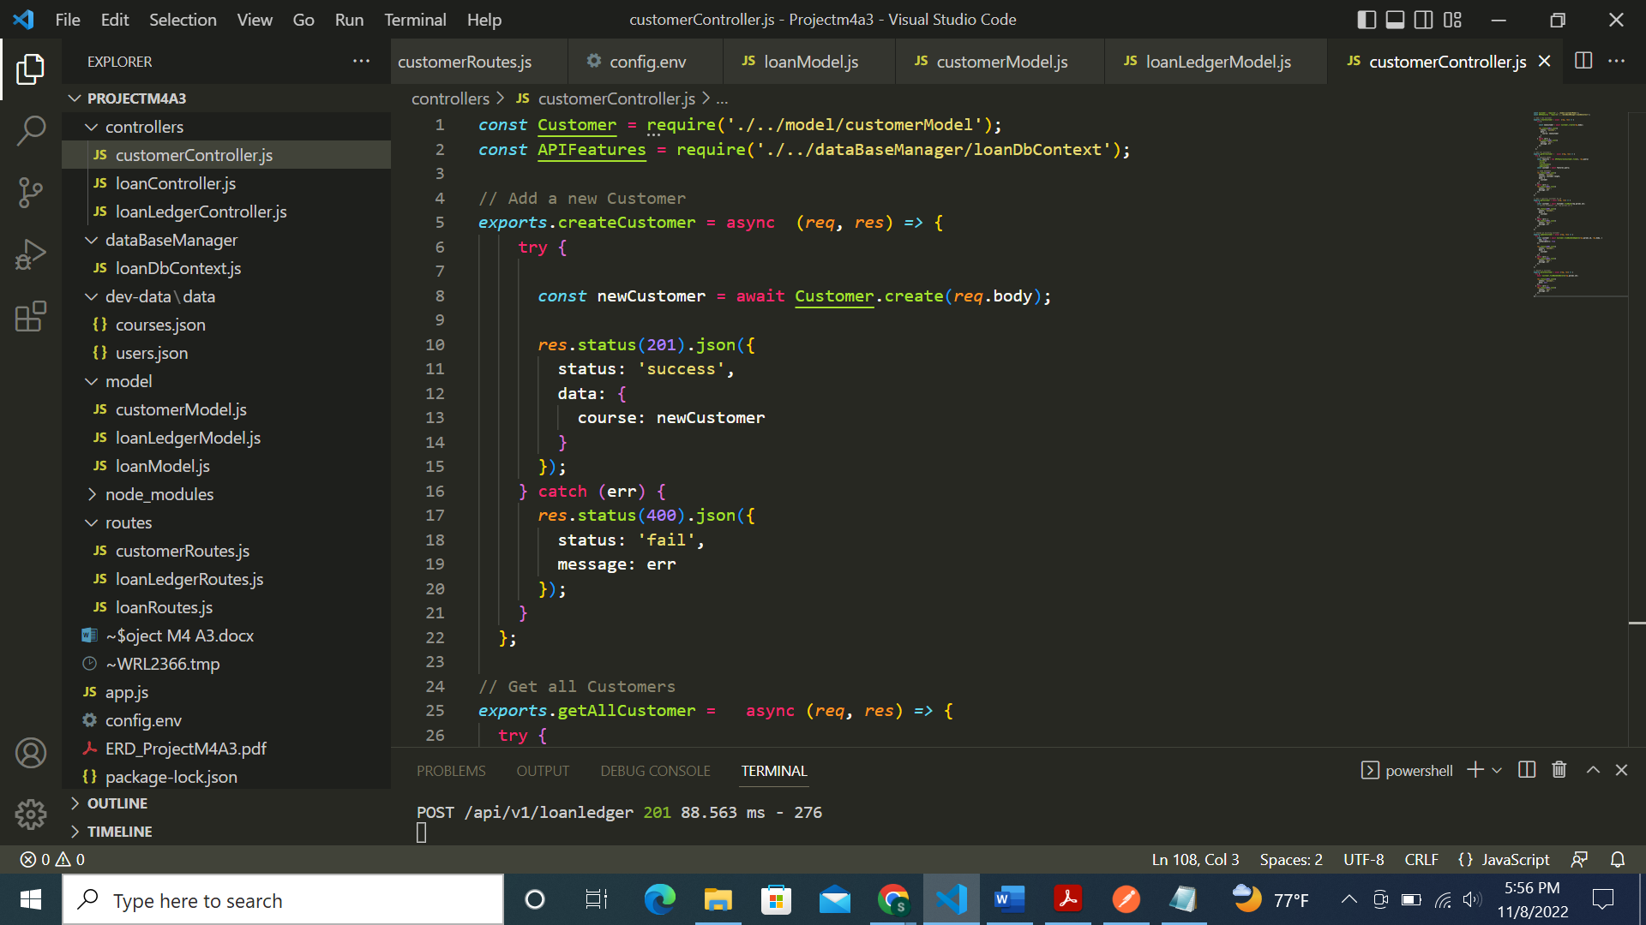

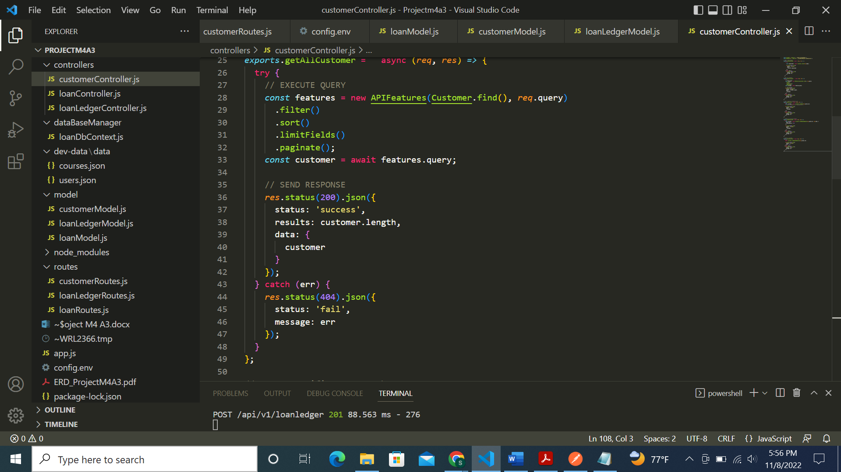

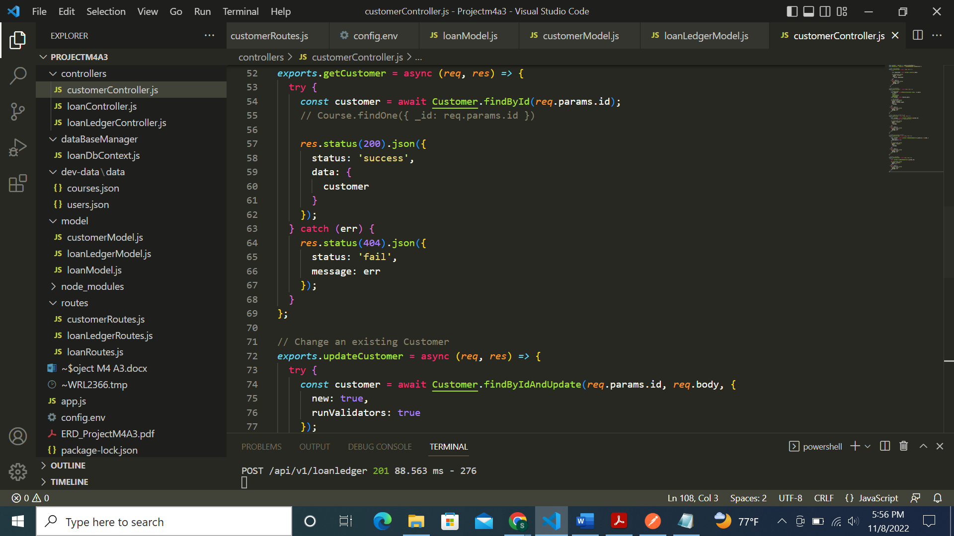

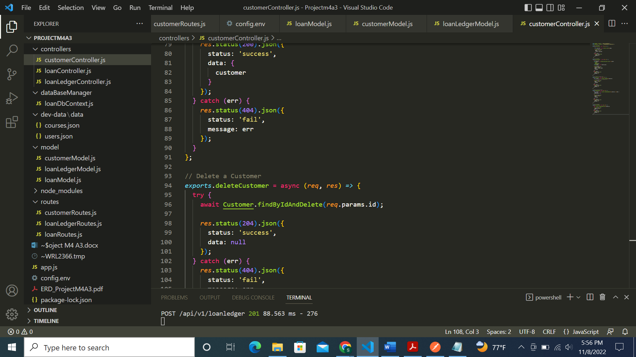

loanController.js file:

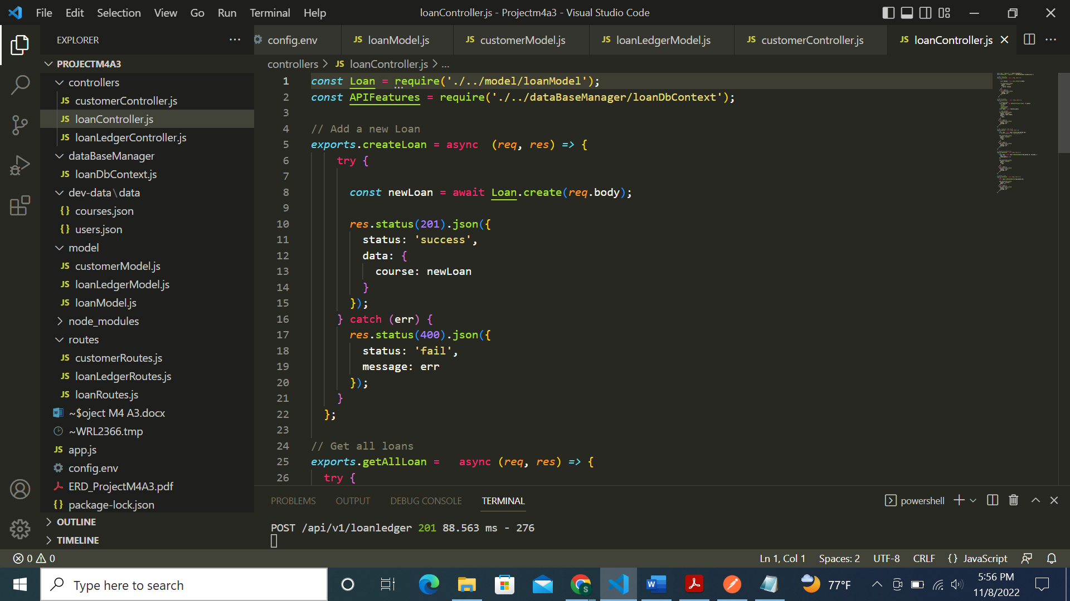

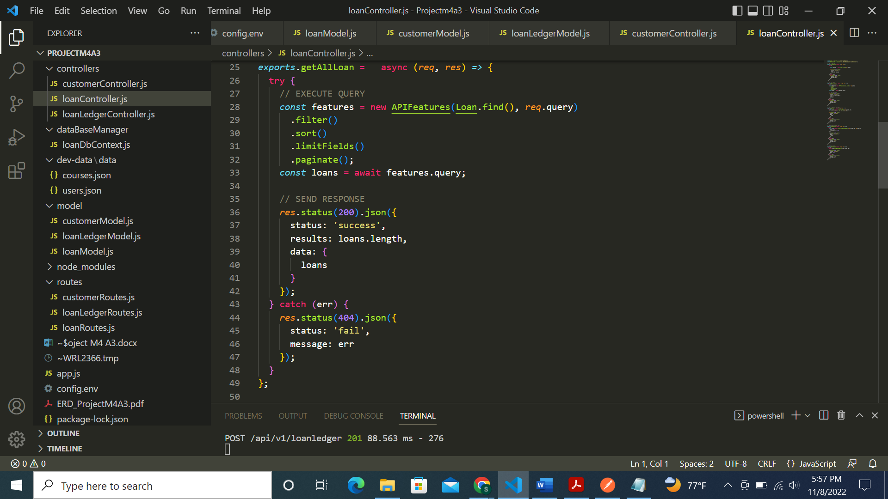

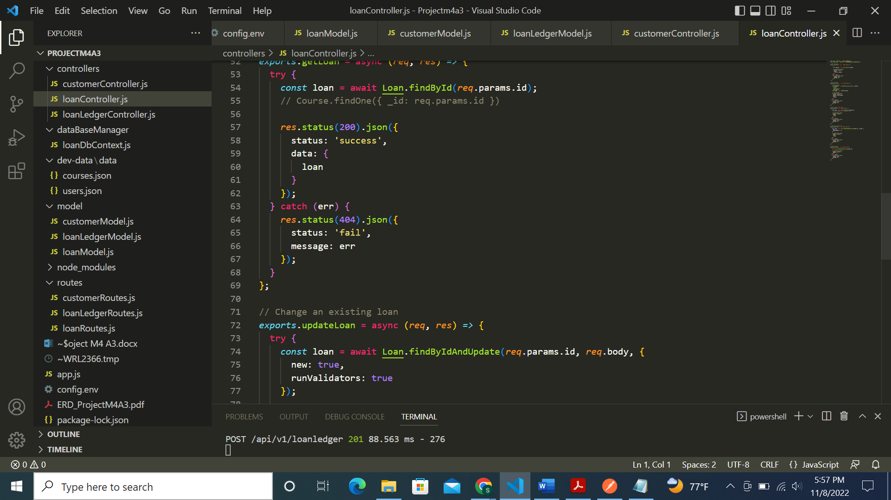

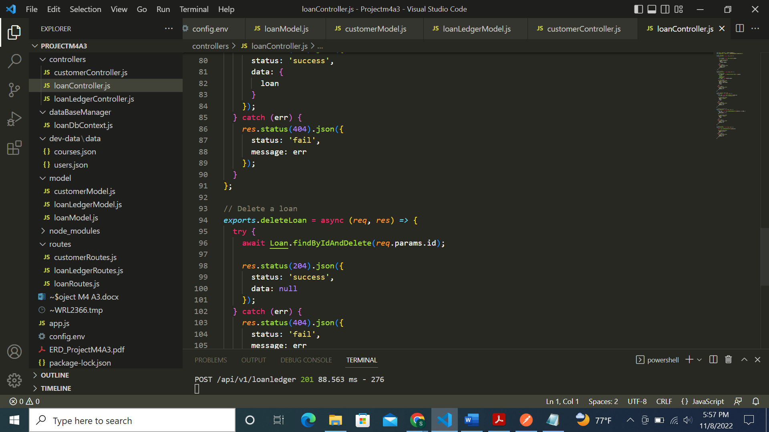

loanledgerController.js file:

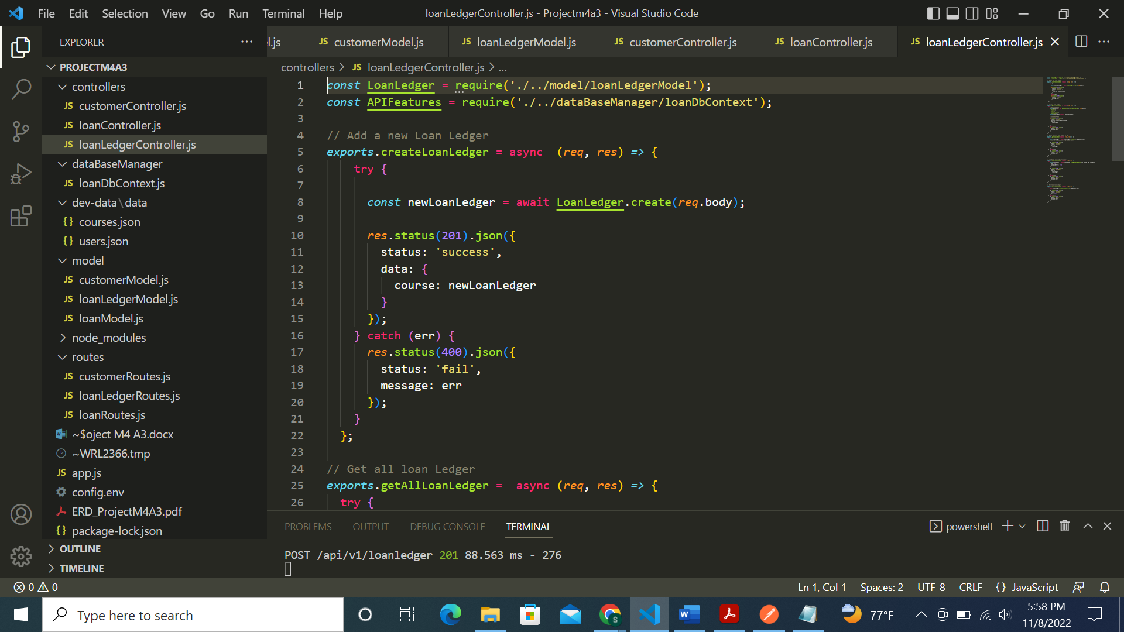

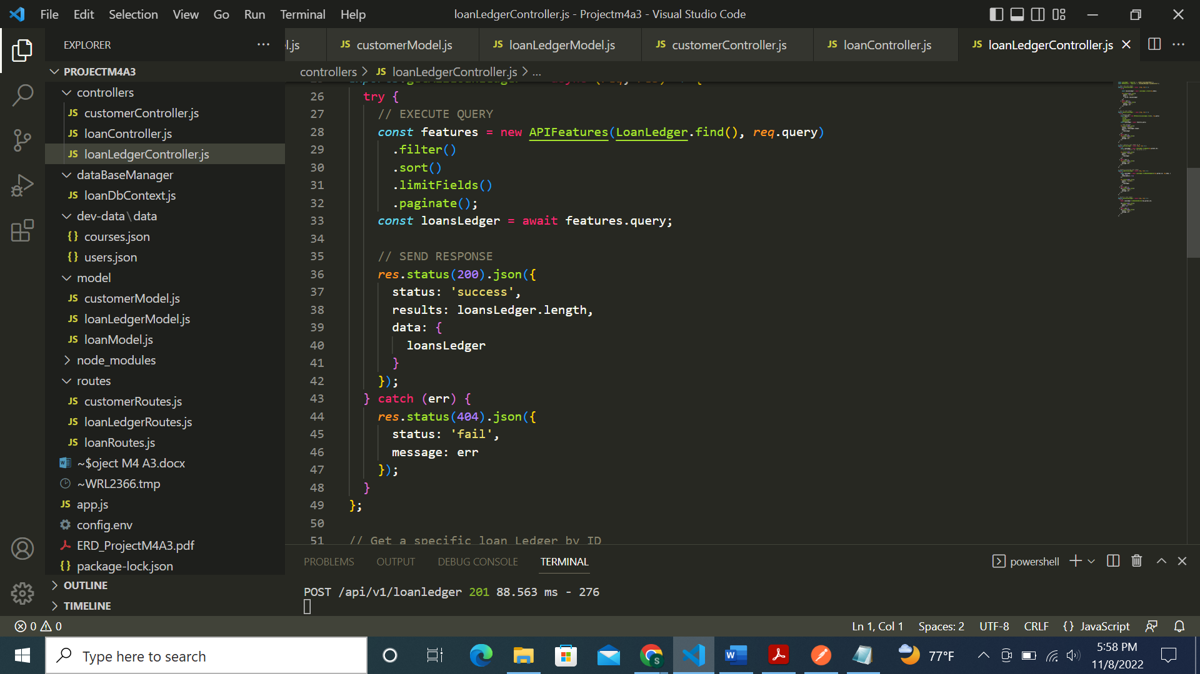

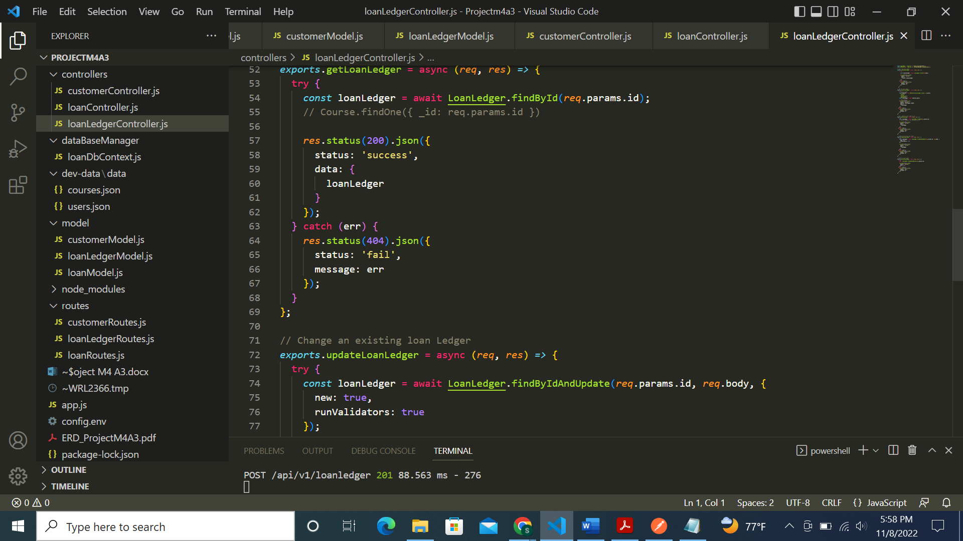

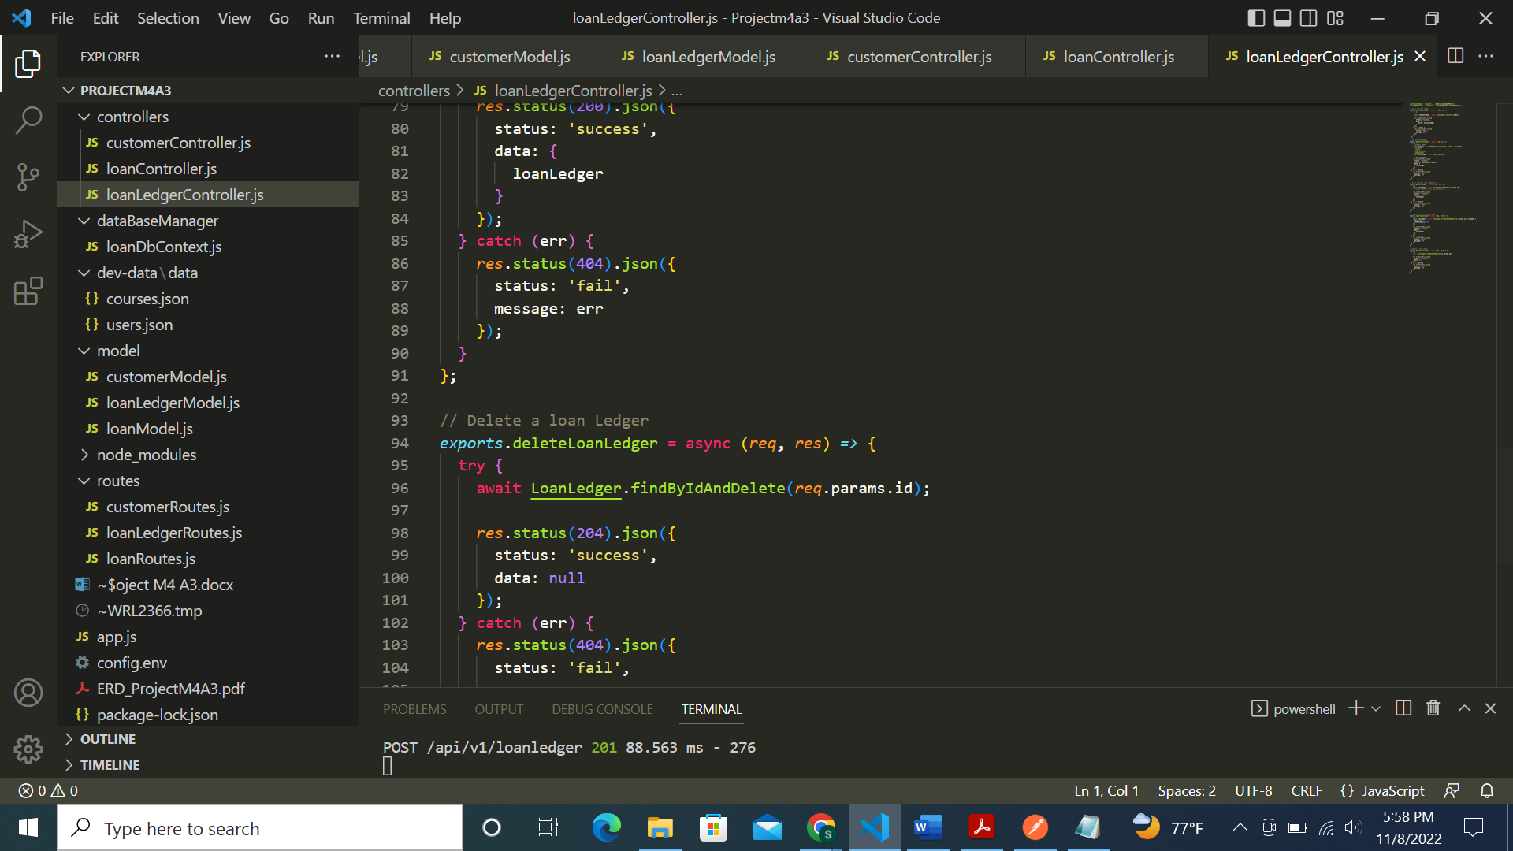

Now screenshot of loanDbContext.js file in dataBaseManager folder:

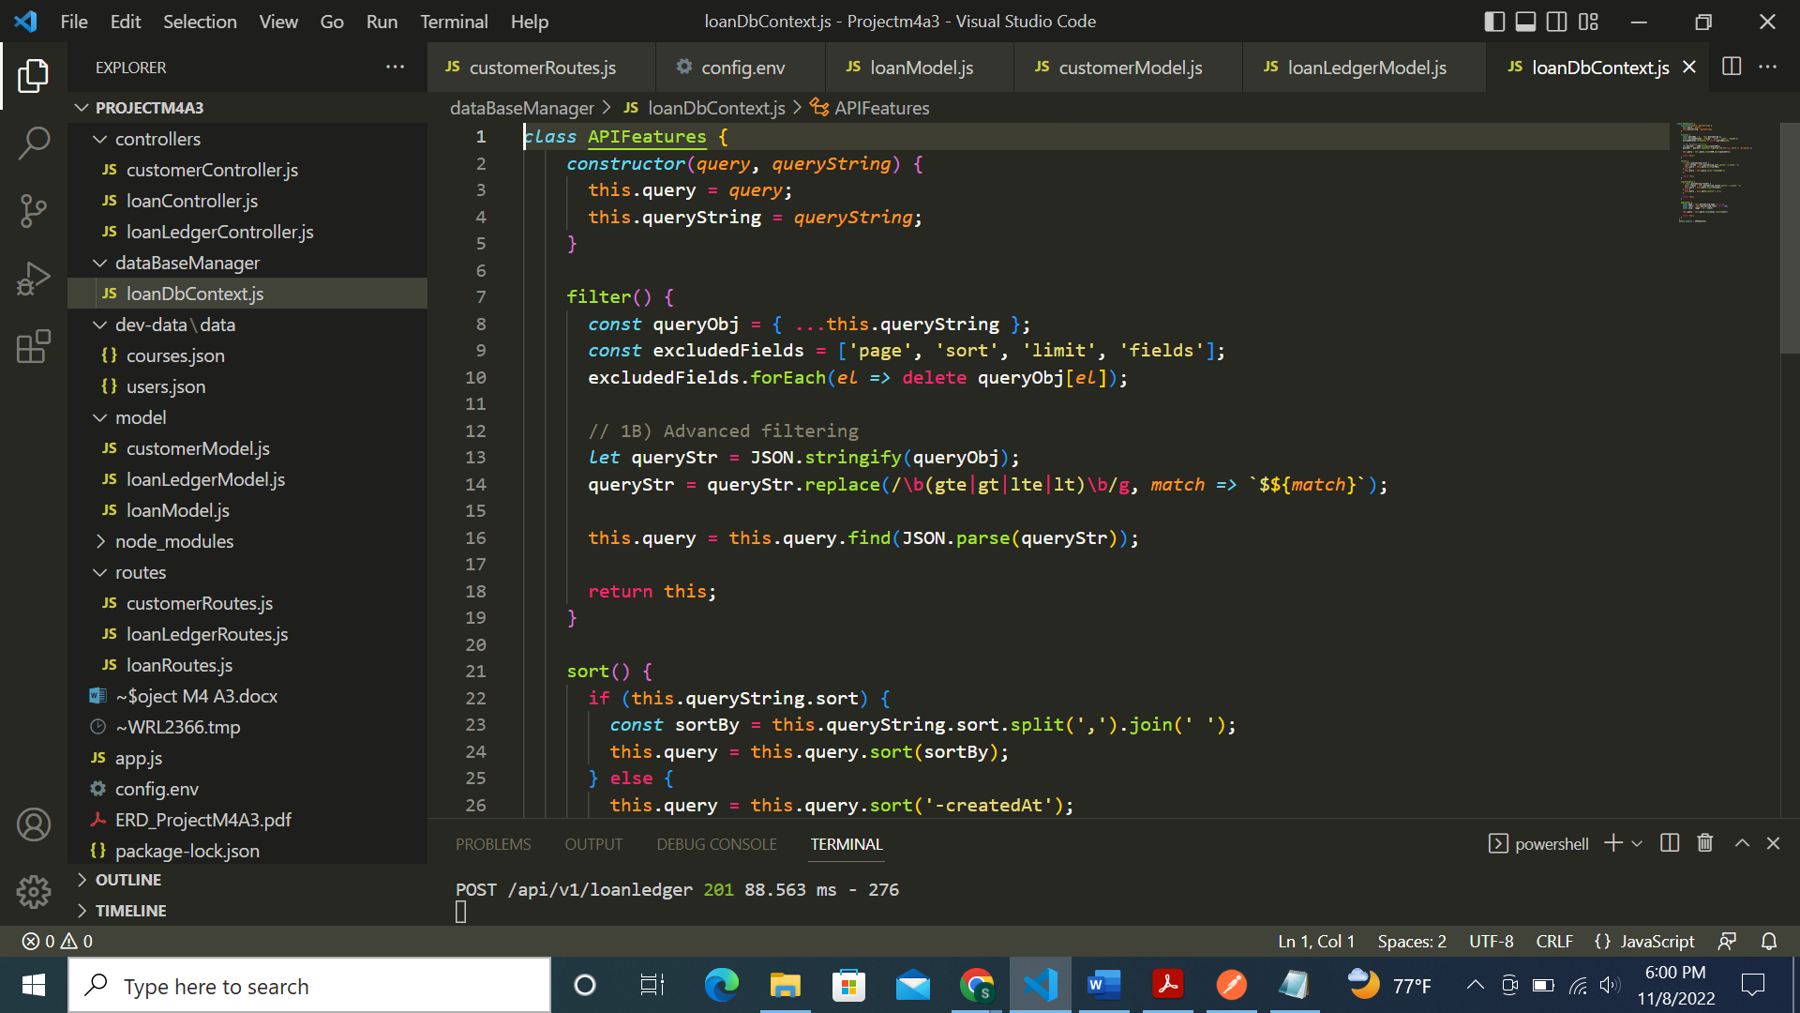

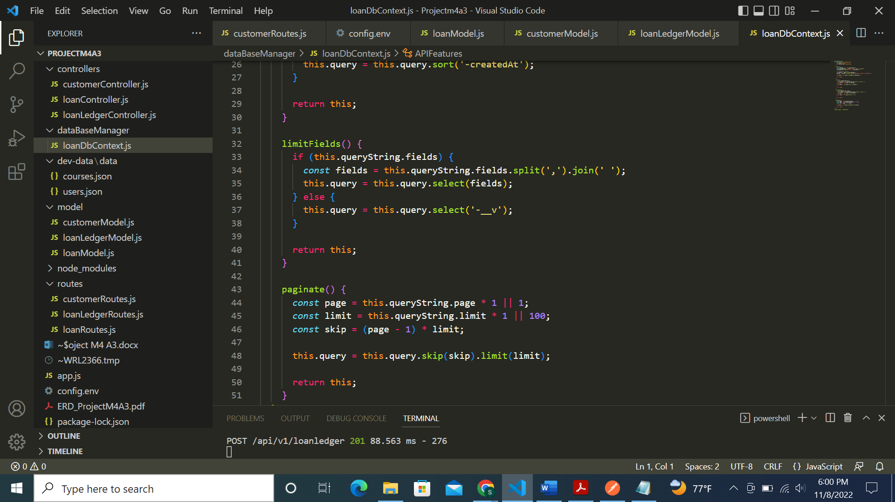

Implementing SELECT (GET), INSERT (POST), UPDATE (PUT), DELETE (DELETE)**:**

For Loan table:

SELECT (GET): successfully getting the 3 loan types

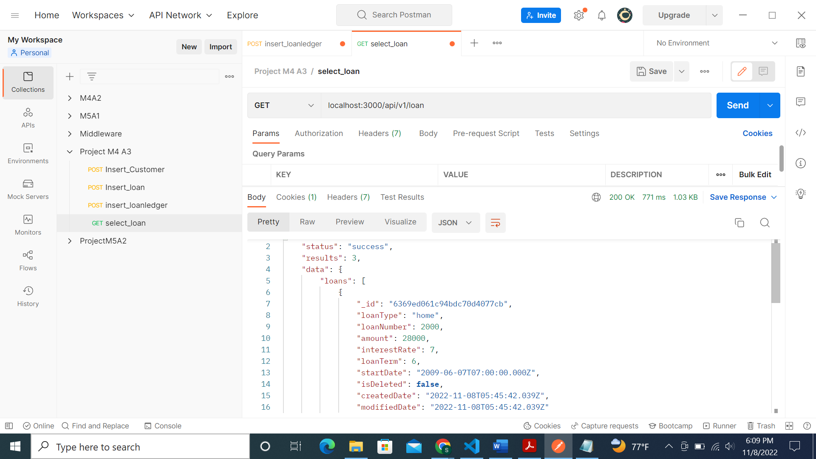

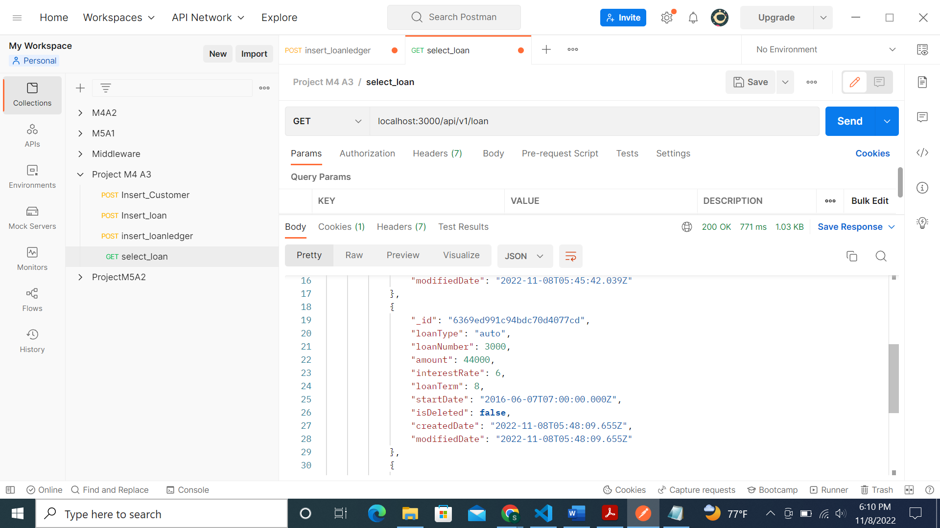

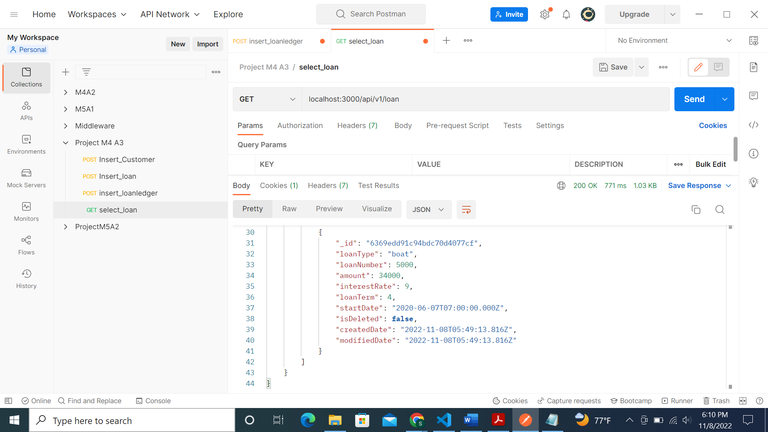

INSERT (POST):

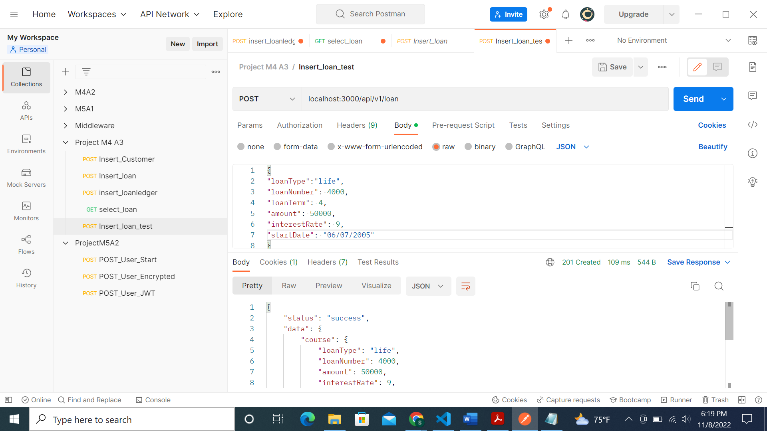

Inserted loan record in MongoDB:

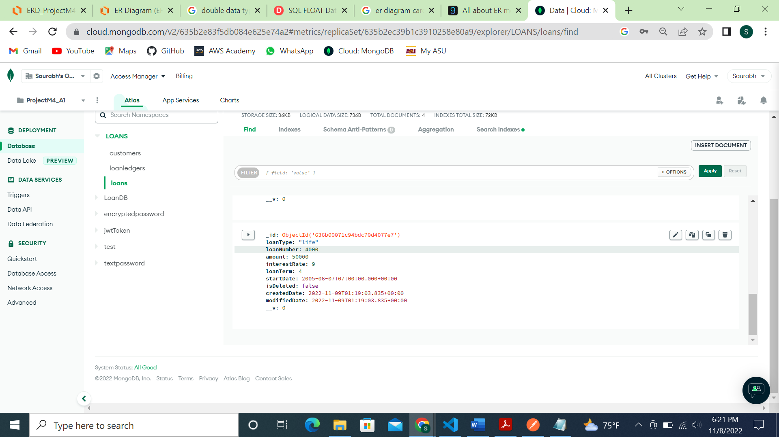

UPDATE (PUT):

Updated life loan record with new amount and new interest rate as 60,000 and 7 respectively:

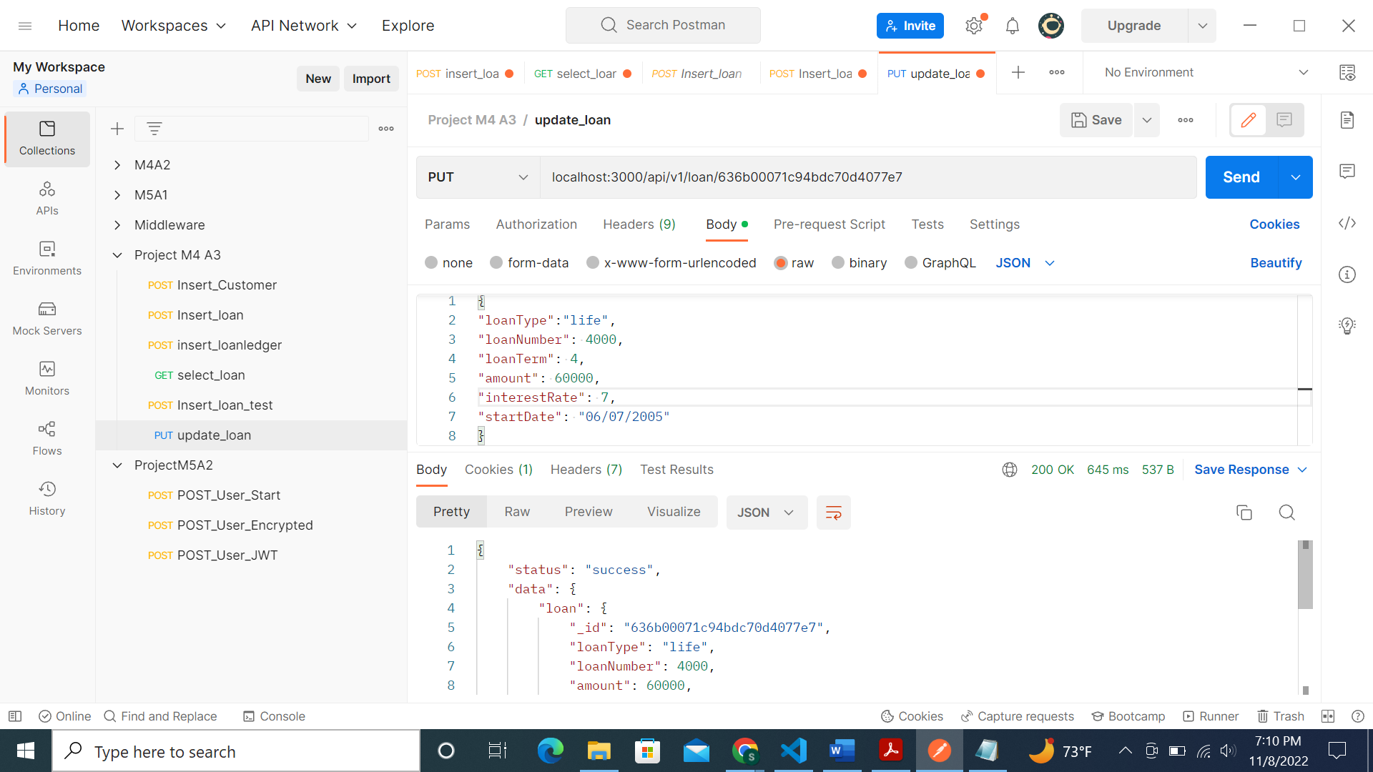

MongoDB update screenshot:

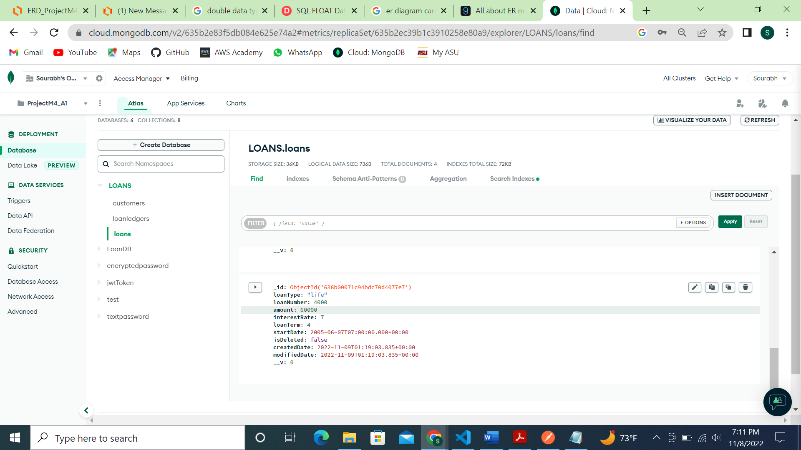

DELETE (DELETE):

Deleted loan record with ID: 636b00071c94bdc70d4077e7

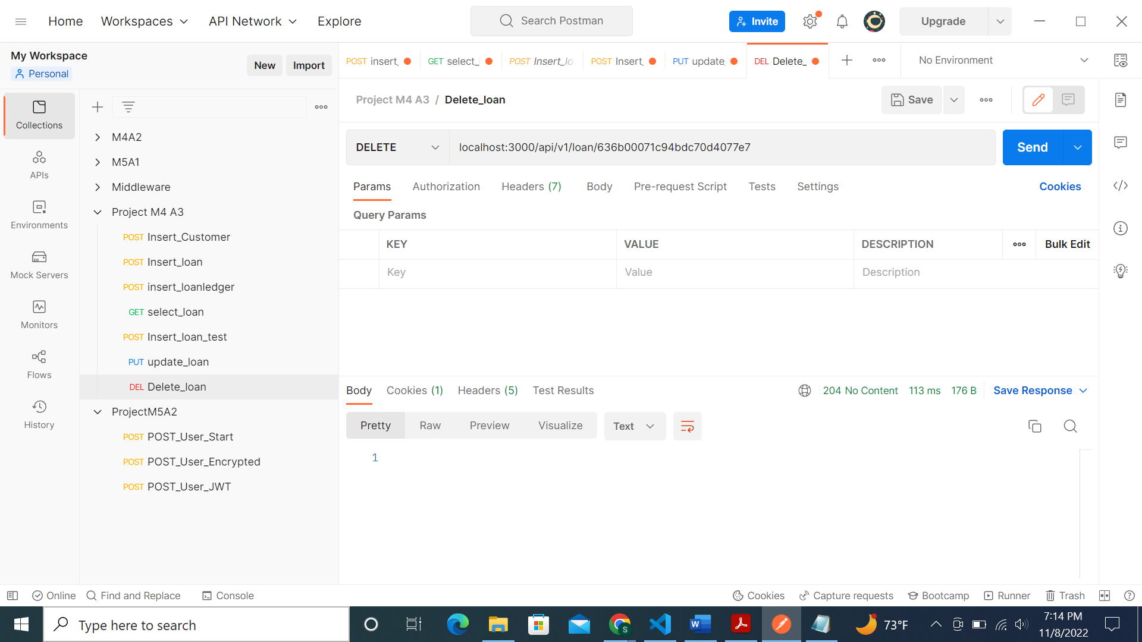

MongoDB screenshot of deleted record:

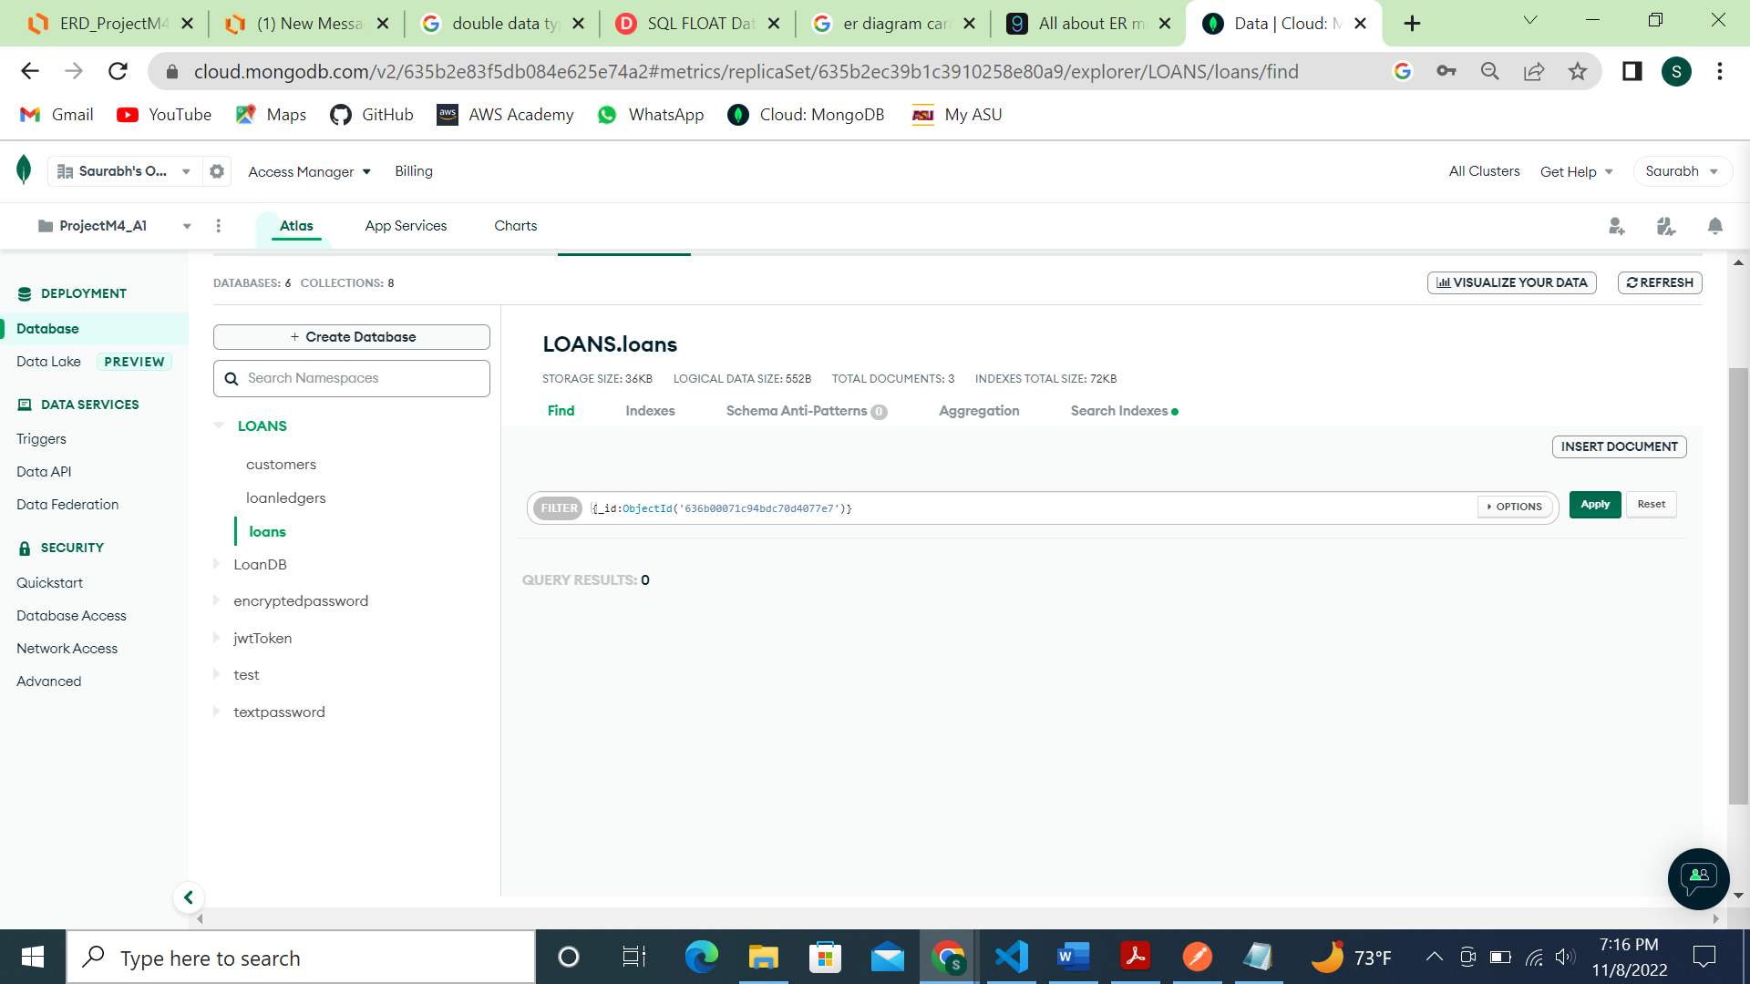

For loan ledger table:

SELECT (GET):

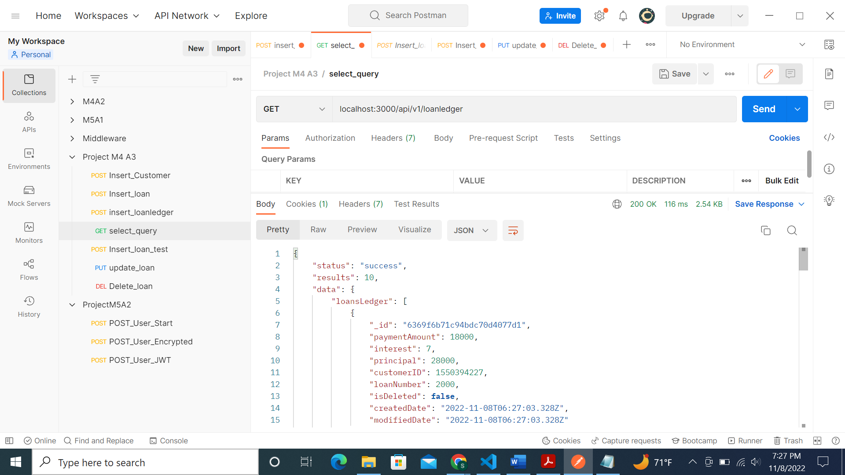

INSERT (POST): Inserted loan ledger with loan number 6002:

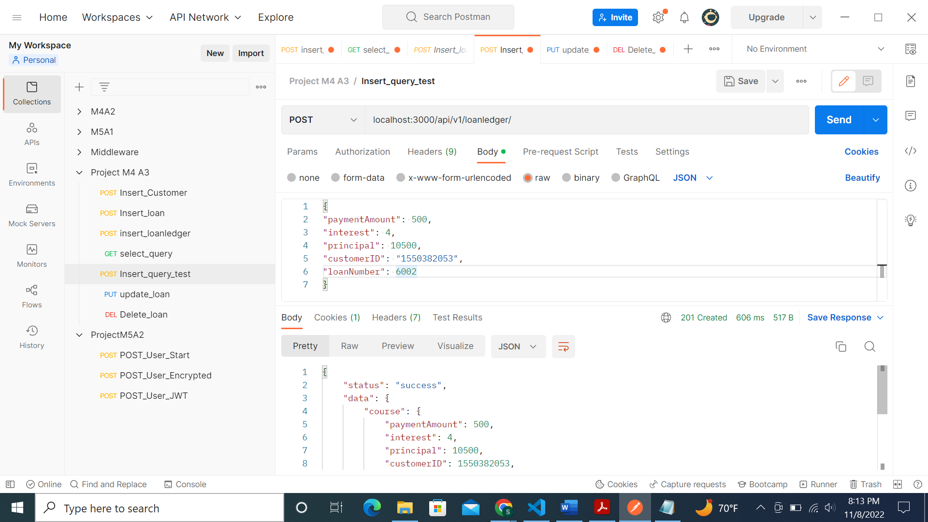

MongoDB screenshot:

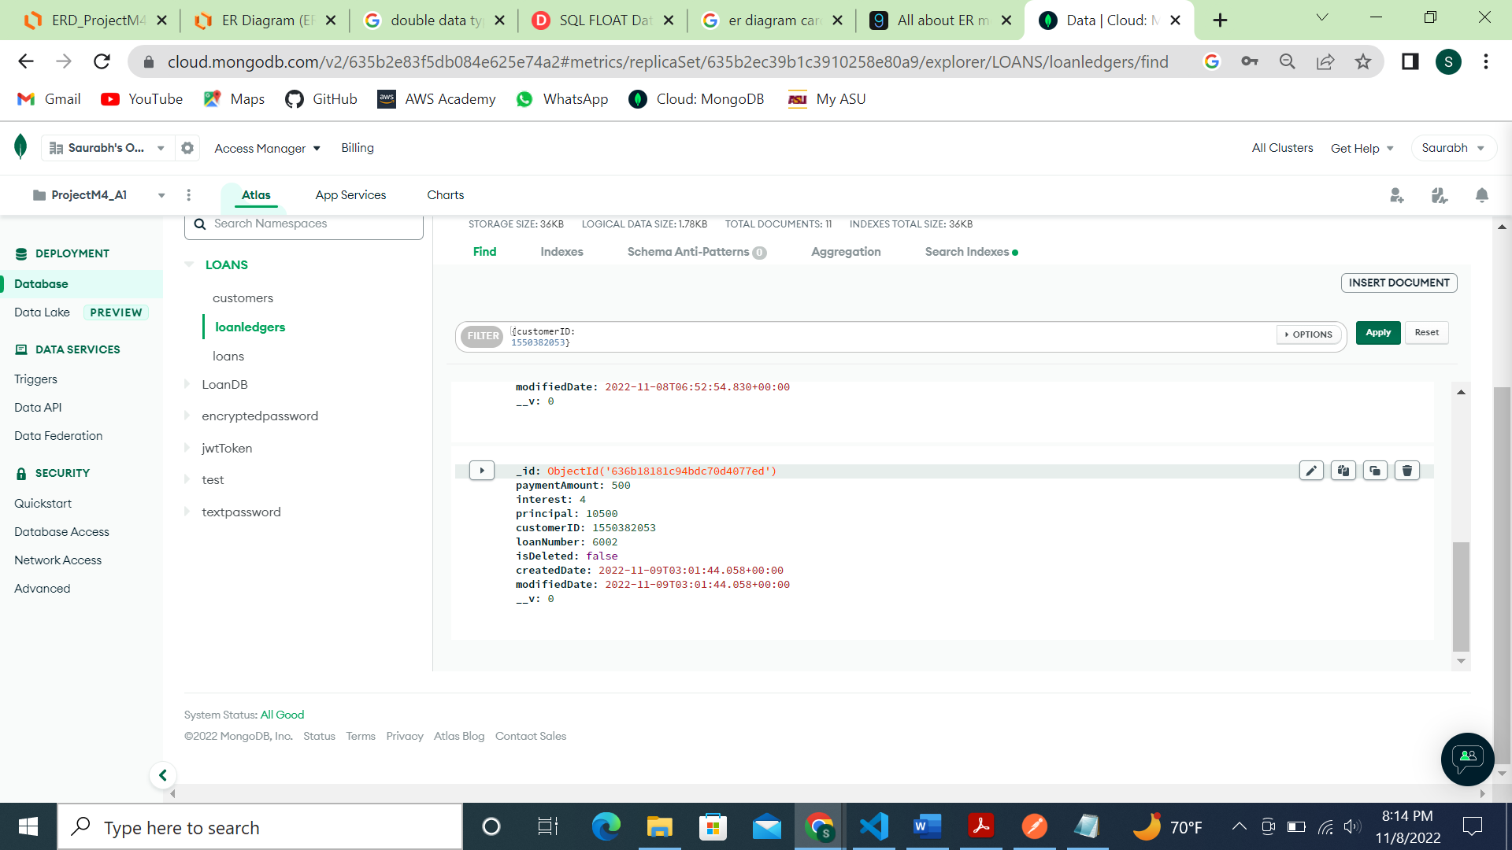

UPDATE (PUT):

Updated inserted loan ledger record:

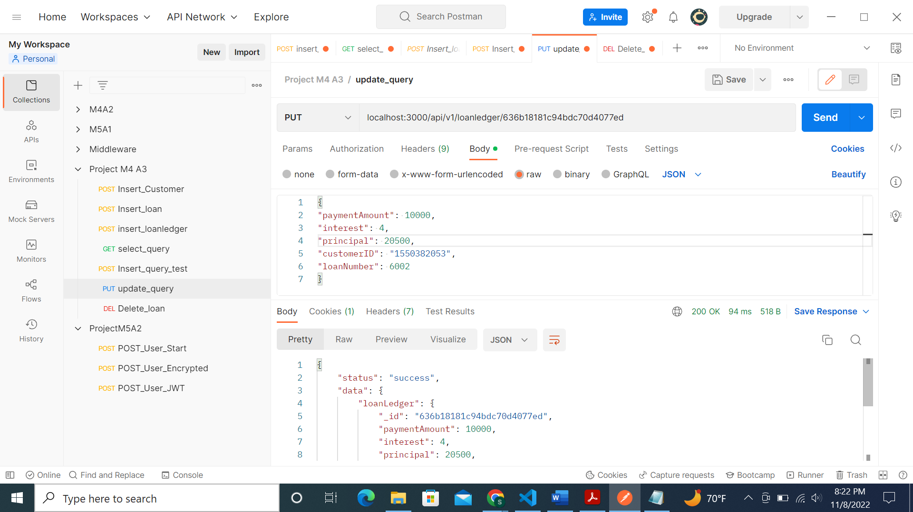

MongoDB screenshot:

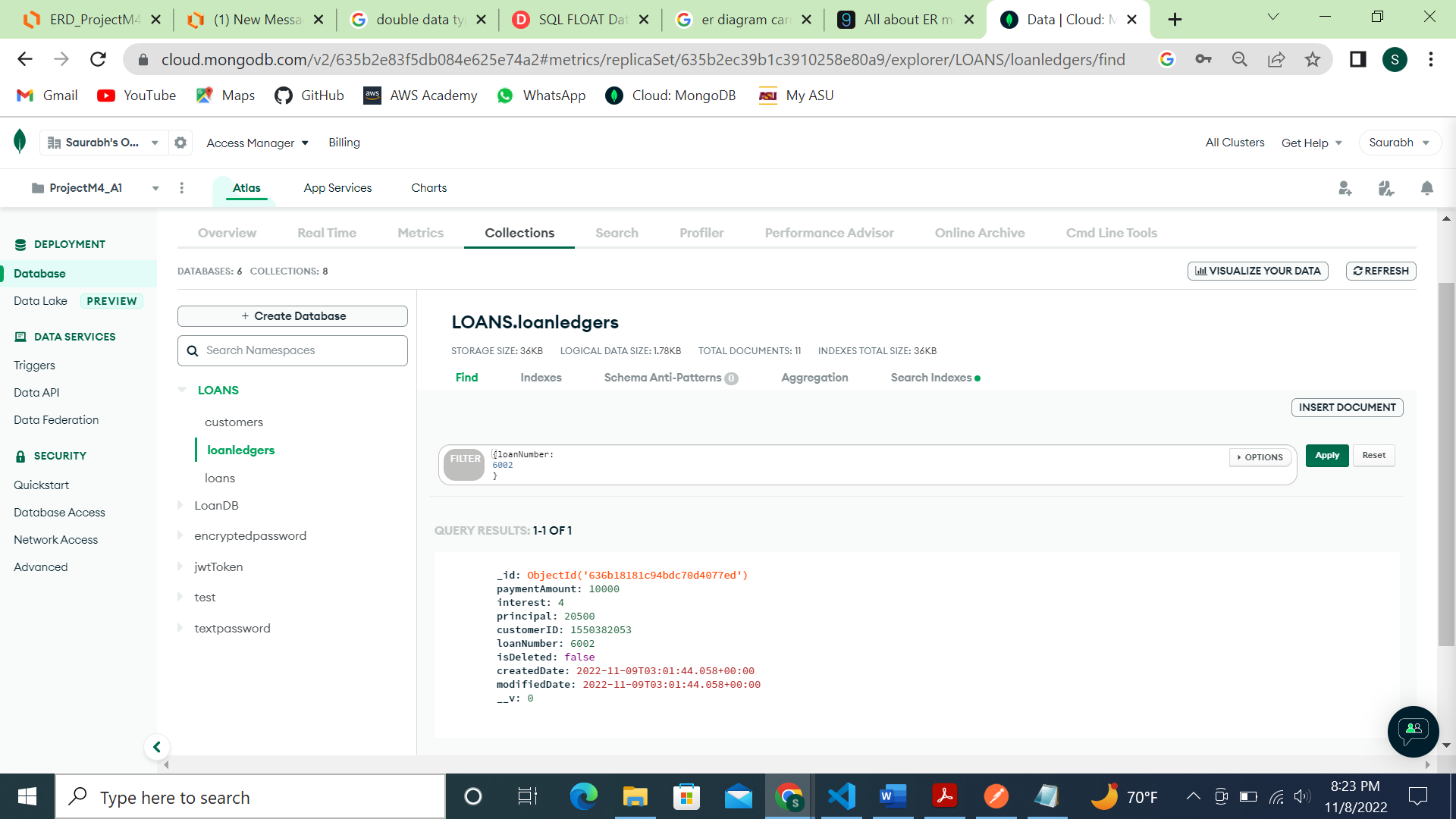

DELETE (DELETE): Deleted inserted loan ledger record:

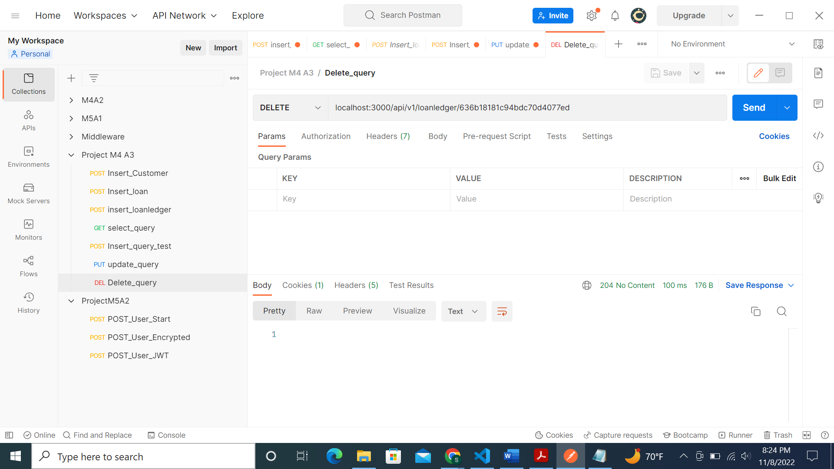

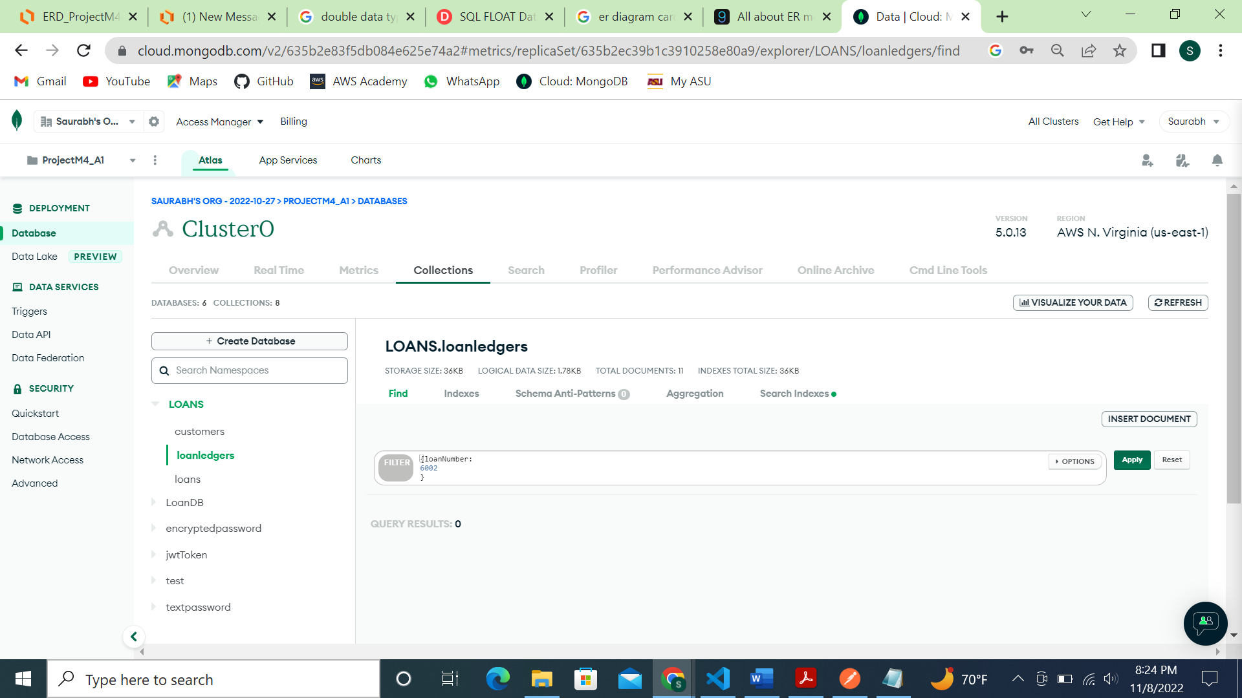

For the customer table:

SELECT (GET):

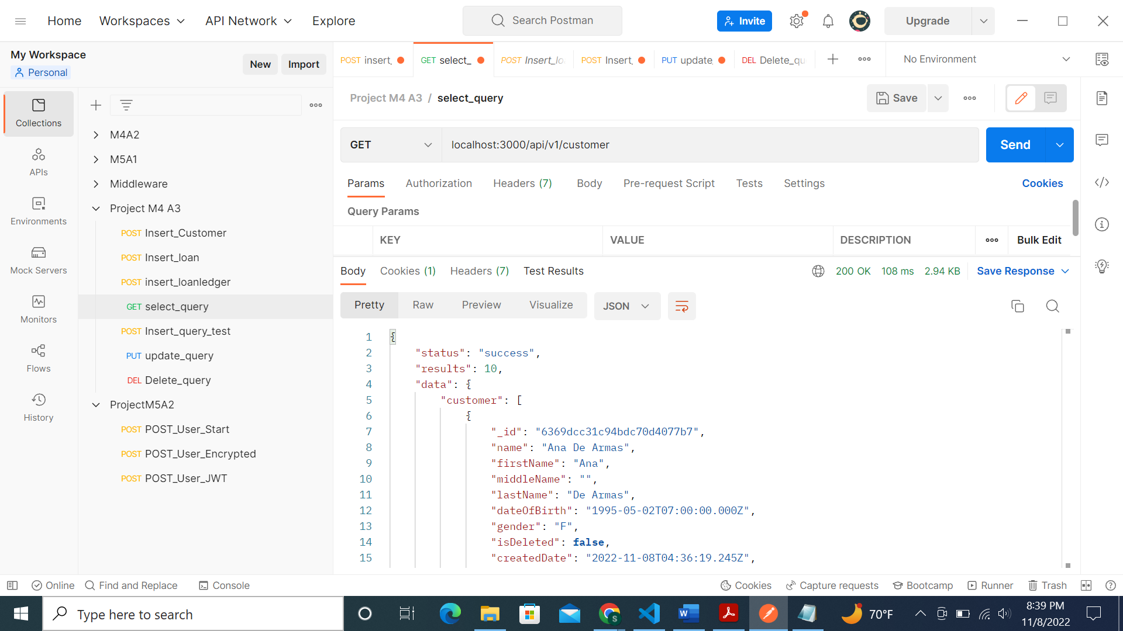

INSERT (POST):

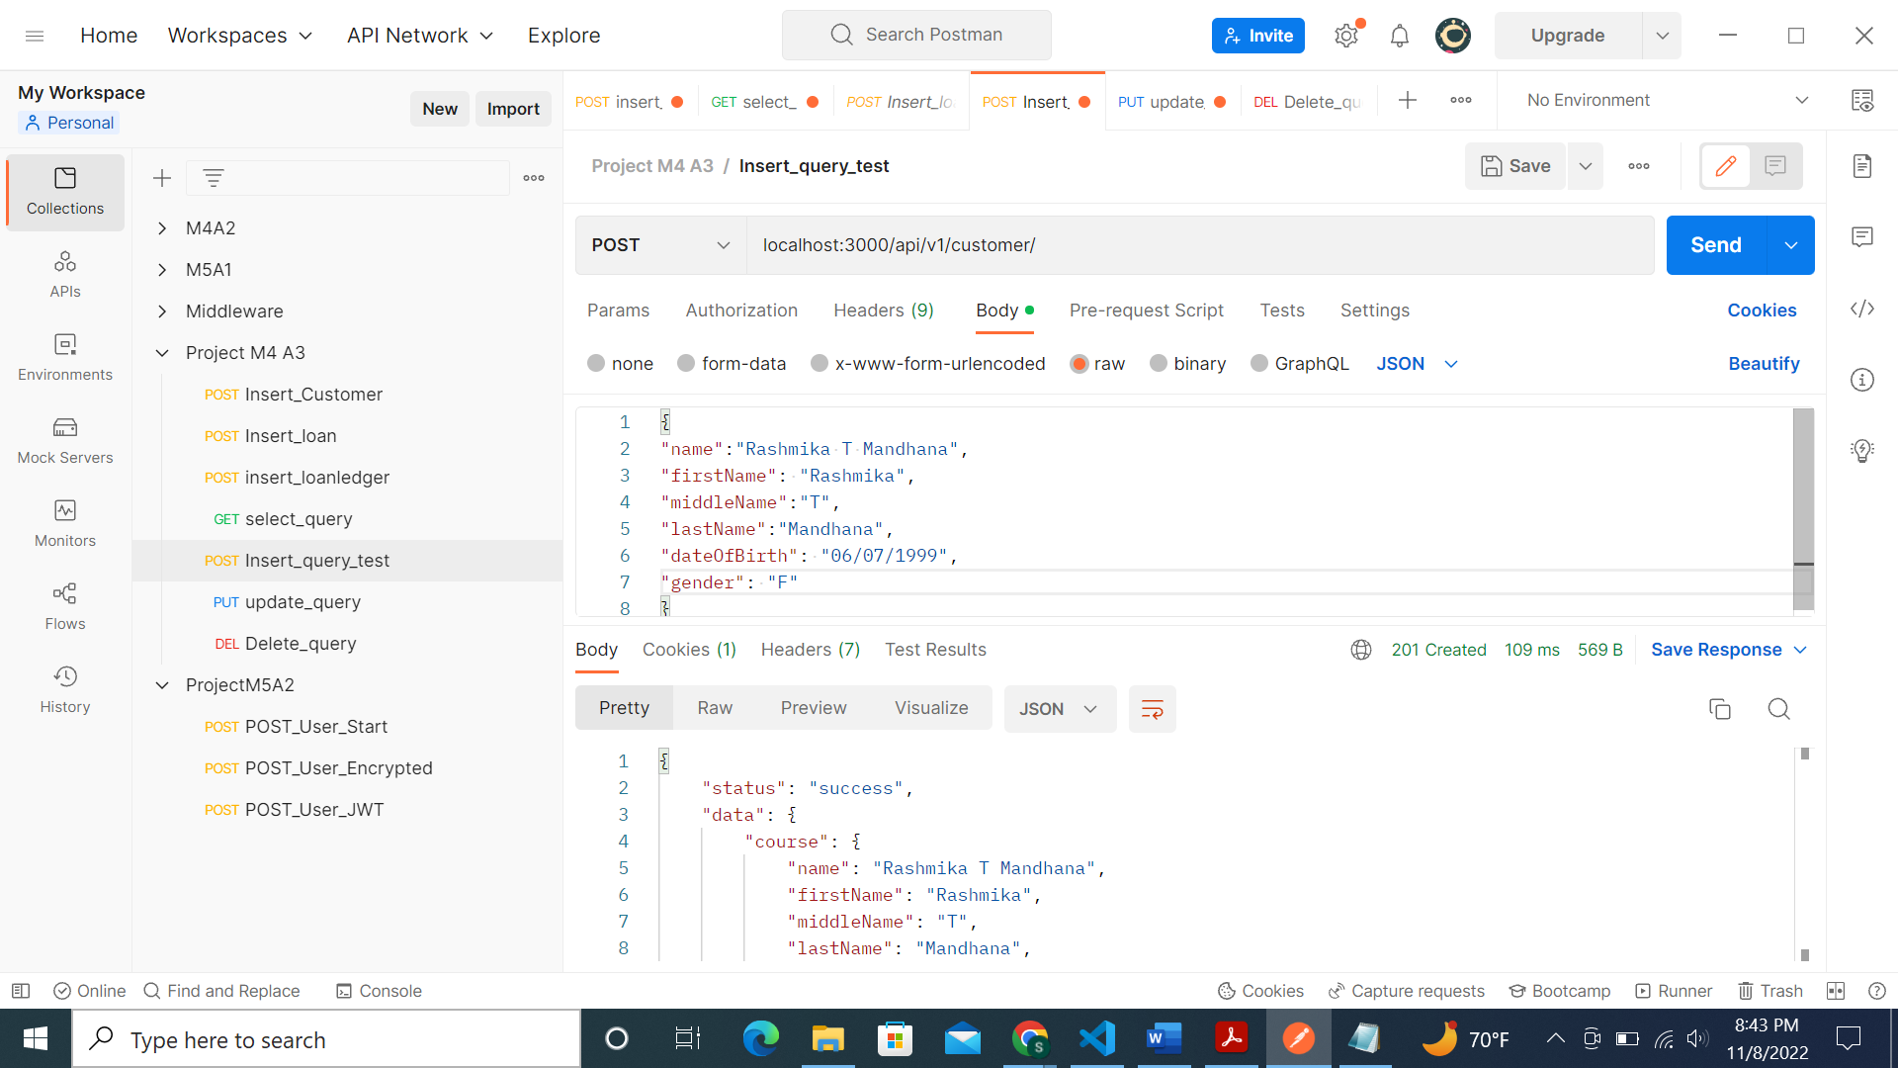

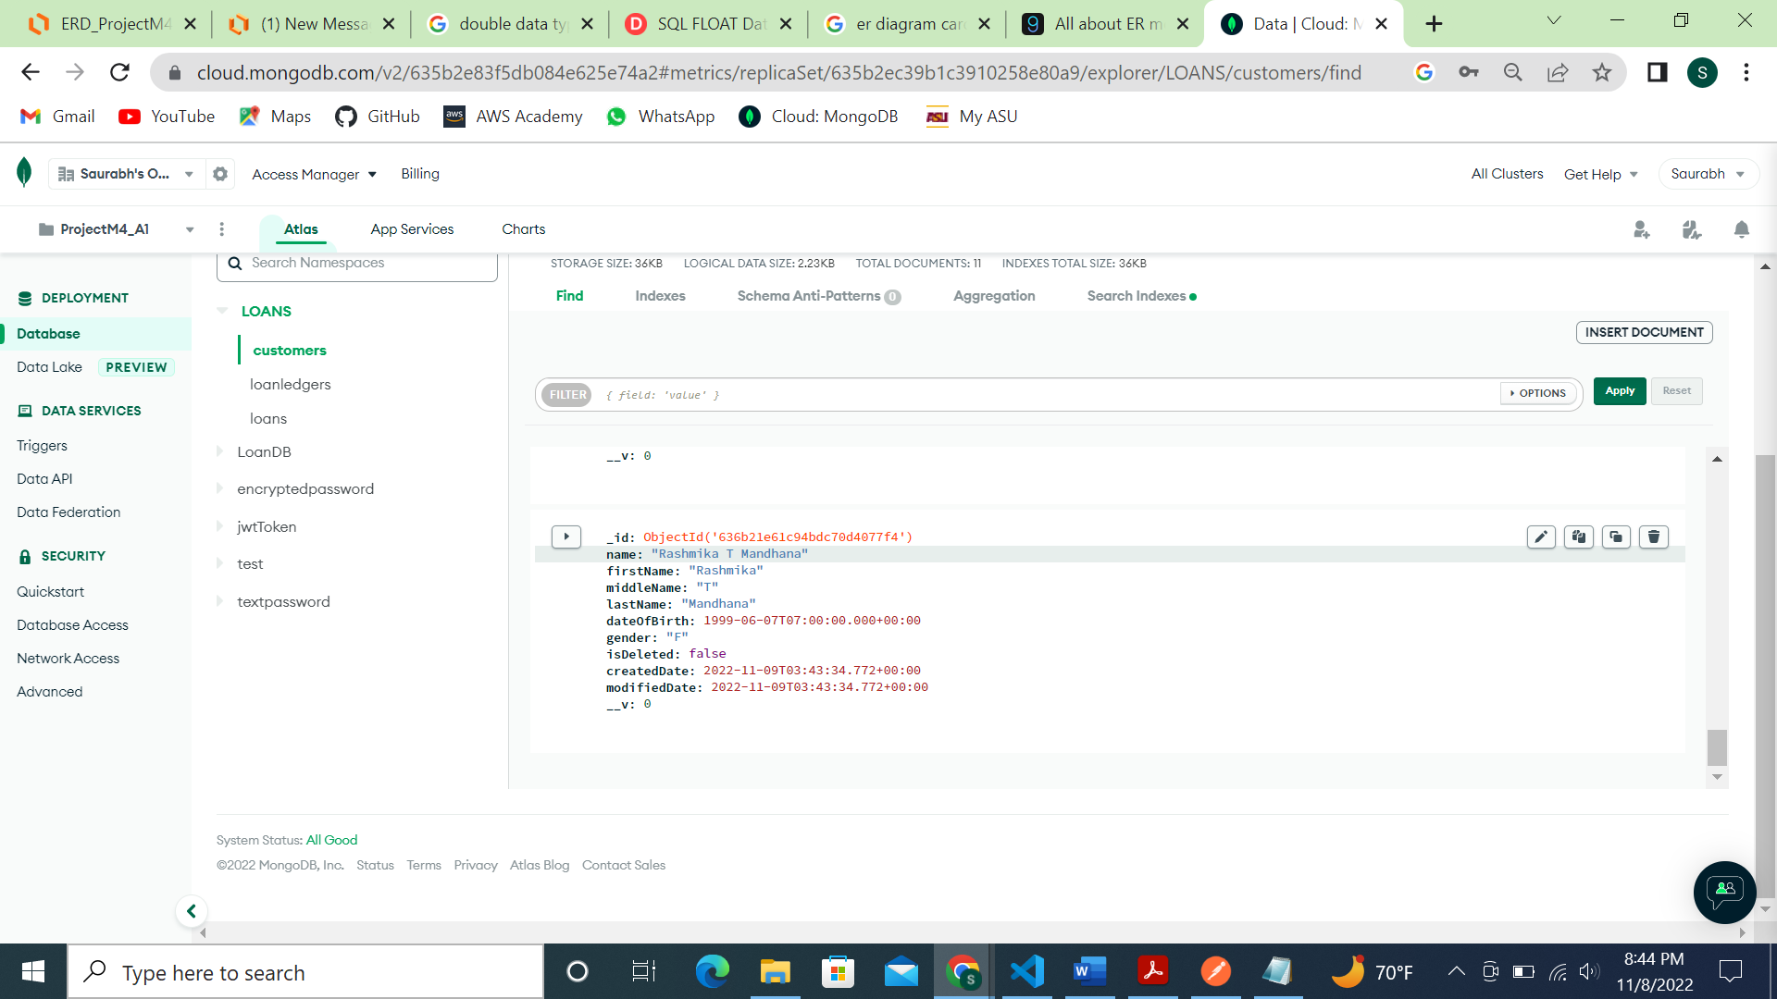

UPDATE (PUT): Update the inserted record:

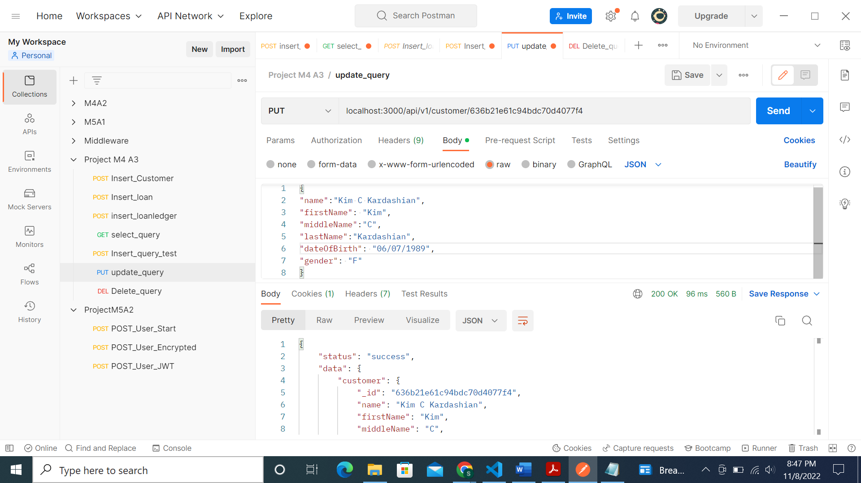

Updated MongoDB screenshot:

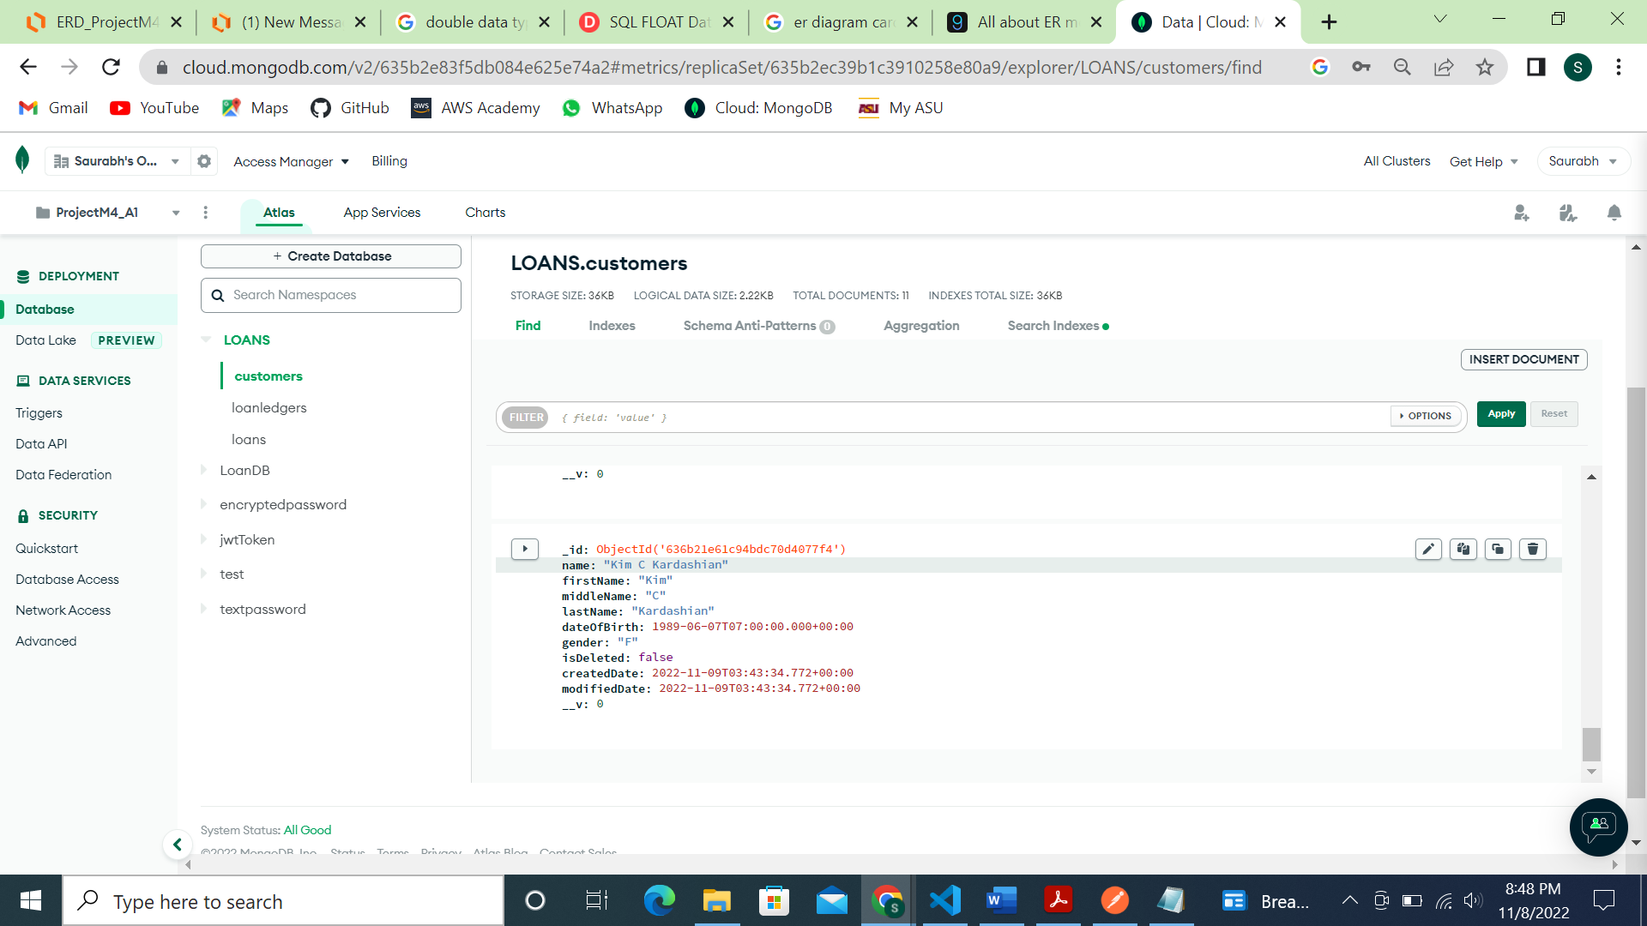

DELETE (DELETE): Deleted the inserted customer record:

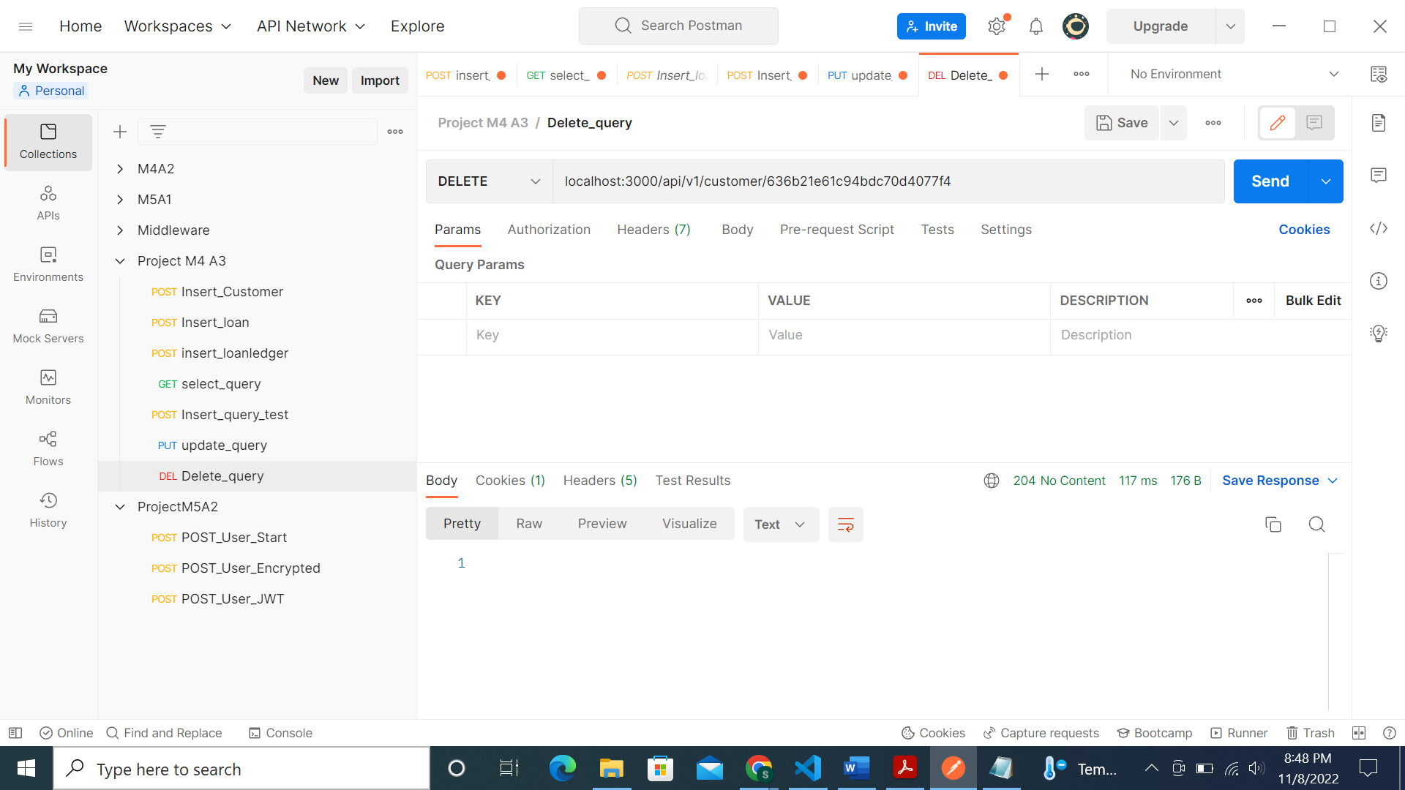

Deleted MongoDB screenshot:

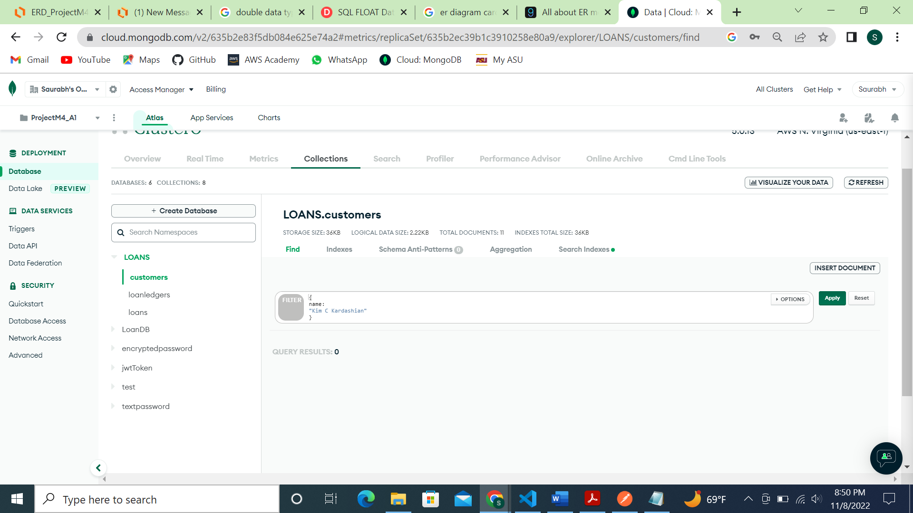

**References**

[10 Database Naming Conventions Best Practices](https://brandongaille.com/10-database-naming-conventions-best-practices/#:~:text=10%20Database%20Naming%20Conventions%20Best%20Practices%201.%20Consistency,for%20a%20single%20entity%2C...%203.%20Plural%20or%20)

[Canvas Assignment page](https://canvas.asu.edu/courses/132658/assignments/3526669?module_item_id=9146149)

GitHub link: